Homeostasis lab
Jane Smith
Partners Names
Block
Biology
Homeostasis and Exercise

Introduction:
The question that was trying to be answered in this lab was “How does exercise affect a person’s heart rate, breathing rate, and perspiration level?” Based on this question, the hypothesis that was formed was “If effects of exercise and exercise are related, then exercising will increase heart rate, breathing rate, and perspiration level”.
Background Information: THIS SHOULD BE PART OF YOUR INTRODUCTION
Before starting the lab report, the important background information that was collected was very helpful while performing the lab. For example, homeostasis is defined according to Dictionary.com as “the ability of the body to maintain relatively stable internal conditions”. Homeostasis in the body is maintained through three vital organs, as mentioned before, the kidneys, liver, and brain. These regulate the temperature, iron content in our blood, retention, and production of energy and overall blood composition. This was helpful because the whole lab report was based on homeostasis and the effect that it had on exercise. Another piece of information that proved to be very important explained the different types of changes that occur during exercise to help the body adjust to maintain equilibrium. These types of changes are perspiration and blood level.

When researching the typed of mechanisms that are used to maintain a constant body temperature, the information that was found was that “our bodies have nerve cells called thermo receptors that measure temperature of our internal body and external environment” (Godbole). When these nerve cells are stimulated by changes inside our bodies and in the world outside, they send their information to the brain, where it is mostly the job of the medulla oblongata to make changes to keep our internal body temperature constant.

Exercise helps keep you fit and healthy by strengthening your muscles and making your heart beat faster. Your muscles, lungs, and heart all work together to move your body and make sure you are getting enough oxygen. This results in an increase in your breathing rate, or rate of ventilation. Your breathing rate is increased due to the fact that “your muscles are working harder then when they are at rest. This means that they need oxygen, along with sugars to complete cellular respiration.” (Why Does Your…) Your heart rate increases so that it can move the oxygen to the target cell in the muscles you are using quicker.

Materials and Methods:
- Materials:
  - People to exercise
  - A clock or stop watch
- Procedure:
  - Choose one volunteer to complete jumping jacks at a pace that can be maintained for eight minutes. Make sure the volunteer is inactive for a few minutes before the experiment begins.
  - Measure the heart rate by taking his or her pulse; you can do this one of two ways:
    - Radial Pulse
    - Carotid Pulse
  - Multiply the number of beats in 15 seconds by 4 to calculate the beats per minute. Record the data in the table below the 0 minutes box.
  - Measure the person’s perspiration level from 0 to 5: (0 = none; 5 = droplets dripping down the face). Note this observation in the table.
  - Have the volunteer do jumping jacks for 2 minutes. After 2 minutes, measure the heart rate, breathing rate, and perspiration level (refer to steps 2 through 5), and record the data. Measure the pulse, breathing and perspiration levels as quickly as you can so that the volunteer can resume exercise. Do not have volunteer wait while you do the calculations and enter the data.
  - Repeat step 6 three more times (remember, 2 minutes each at a time, totaling 8 minutes) and record your data at each point.
  - After the final recording of the dependent variables, wait one minute with the volunteer at reset. Then measure all of the variables again. Record this data under the “9 Time (Min.) Box”.

Data and Observations:
Table 1: Effect of Exercise
Total Time  (Minutes) | Heart Rate  (Beats per Minute) | Breathing Rate  (Breaths per Minute) | Perspiration Level  (Scale of 0 to 5)
0 – Prior to Exercise | 84 | 36 | 0
2 Minutes | 128 | 52 | 0
6 Minutes | 96 | 36 | 1
8 Minutes | 120 | 40 | 2
9 Minutes | 144 | 44 | 2

Table 1: shows the heart rate, breathing rate and perspiration level of exercisers over nine minutes

Table 2: Effects of Exercise: Class Averages
Variables Measured |  | Group  1 | Group  2 | Group  3 | Group  4 | Group  5 | Averages:
Heart  Rate | Start: | 68 | 104 | 104 | 98 | 84 | 73
Heart  Rate | Finish: | 38 | 152 | 120 | 120 | 144 | 115
Breathing Rate | Start: | 20 | 60 | 60 | 16 | 36 | 38
Breathing Rate | Finish: | 68 | 68 | 68 | 32 | 44 | 56
Perspiration  Level | Start: | 0 | 0 | 0 | 0 | 0 | 0
Perspiration  Level | Finish: | 1 | 3 | 0 | 0 | 2 | 1

Table 2: shows the averages of the entire group’s heart rate, breathing rate and perspiration levels at the start and finish of exercising
Graph 1: Effects of Exercise
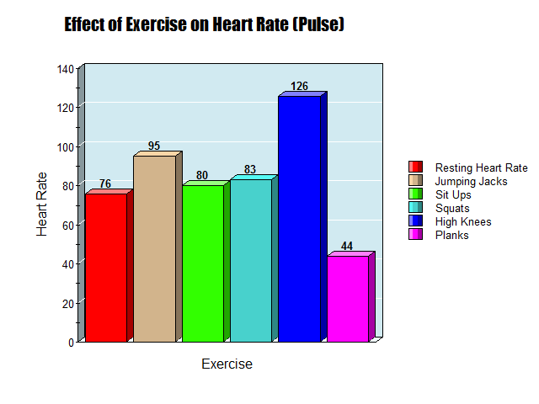
Analysis:
There is an increase effect of exercise over time on the circulatory and respiratory systems, as shown in both Table 1 and Table 2. As the students began their exercise in two-minute intervals, their heart rates increased on average from 73 beats per minute to 115 beats per minute. Shawn’s individual heart rate began at 84 beats per minute, and after lifting 5-pound weights for 8 minutes, his heart rate increased to 114 beats per minute. Also, his breathing rate showed an increase from 36 breaths per minute to 44 breaths per minute. Based on this data shown, the amount that you exercise does effect the circulatory and respiratory systems by causing a, on average, dramatic increase in beats/breath per minute in the measured variables.

Conclusion:
According to the data collected, the hypothesis that was developed at the beginning of the experiment: “If effects of exercise and exercise are related, then exercising will increase heart rate, breathing rate, and perspiration levels”; was accepted. Based on the data shown our individual group charts and the class averages, the effect that exercise has on the respiratory and circulatory systems is that it develops an increase in heart rate (Start: 73/ Finish: 115), breathing rate (Start: 38/ Finish: 56), and perspiration levels (Start: 0/ Finish: 1).

Another process that could have been used to measure the external and internal effects of exercise on the body could be to also measure the body temperature before and after the exercise is preformed. This could be a good variable to measure because often the amount of perspiration found on a body is a result of the internal and external body temperature. The relationship between the perspiration level and the body temperature is that they are both negative feedback. After exercise, the body tries to return to homeostasis; so when the body temperature increases due to exercise, the body perspires to cool off and return to its regular temperature, which is considered negative feedback.

Validity:
Three ways of improving the Homeostasis and Exercise lab are as followed-More trials preformed could help the development of a more clear trend throughout the data Everyone using the same amount of weights, and doing the same type of lifting could eliminate the chances of one person working/exercising harder than another Using a more accurate tool to measure the amount of time, such as a stopwatch, could improve the validity of the experiment because it would ensure that all of the volunteers are exercising and resting for the same amounts of time.

Works Cited

Godbole, Medha. "Maintaining Homeostasis." Buzzle.com. Buzzle.com, 22 Sept. 2011. Web. 18 Sept. 2012. <http://www.buzzle.com/articles/maintaining-homeostasis.html>.

"What Mechanisms Maintain Constant Body Temperature?" WikiAnswers. Answers, n.d. Web. 18 Sept. 2012. <http://wiki.answers.com/Q/What_mechanisms_maintain_constant_body_temperature>.

"Why Does an Increase in Pulse Rate and Breathing Rate Accompany Exercise?" WikiAnswers. Answers, n.d. Web. 18 Sept. 2012. <http://wiki.answers.com/Q/Why_does_an_increase_in_pulse_rate_and_breathing_rate_accompany_exercise>.

"Why Does Your Breathing Rate Increase During Exercise?" LIVESTRONG.COM. N.p., n.d. Web. 18 Sept. 2012. <http://www.livestrong.com/article/149316-why-does-your-breathing-rate-increase-during-exercise/>.

