Russian Jewish Clothing for Children

1. Traditional Russian Clothing for Children
http://www.rusclothing.com/traditional-russian/children/

2. Pictures Below
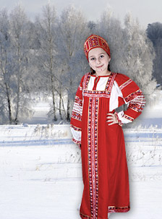

http://images.google.com/imgres?imgurl=http://www.diversehamilton.ca/Pictures/russia_cat_russian_clothing.jpg&imgrefurl=http://www.diversehamilton.ca/europeanCommunity/russian.html&usg=__pwRJDypv6ENwggAPbDbtYTiiokM=&h=303&w=224&sz=27&hl=en&start=25&tbnid=8v5SPTEH--FrJM:&tbnh=116&tbnw=86&prev=/images%3Fq%3Dtraditional%2Brussian%2Bjewish%2Bfolk%2Battire%26start%3D20%26ndsp%3D20%26hl%3Den%26rlz%3D1T4DKUS_enUS278US278%26sa%3DN

