

TECH BYTES

**Orange Board of Education March 2018**

January 2013



**Take Classroom Video to the Next Level**

**Learn how students can be active viewers when you use video in the classroom**

When you show video in your classroom, you want your students to be active viewers — to comprehend, not just consume. But why stop at comprehension? When it comes to video in the classroom, students shouldn’t just get what they’re watching; they should have something to say about it. Check out the video for tips on how to help students become better active — and reactive — viewers in class.

There's so much great video content out there and it's never been more accessible but teachers know that when you show a video in class you want to make sure your students are really digging in and not just sitting back. So before you press play keep these active viewing tips in mind have students take notes pause the video and make sure students get what they're watching and offer multiple viewings to reinforce key concepts. Of course no one method is perfect for all the videos. Active viewing is cool but students shouldn't just be active viewers they should also be reactive viewers. Students need to understand the videos they watch but they should also have something to say about that they need to comprehend and critique read and react. It starts with developing an essential question before students watch, you've got to give them something to latch on to, it'll help them get it and have an opinion on what they're seeing. . Check out the [video](https://www.commonsense.org/education/asset/video/take-classroom-video-to-the-next-level) for tips on how to help students become better active — and reactive — viewers in class.

[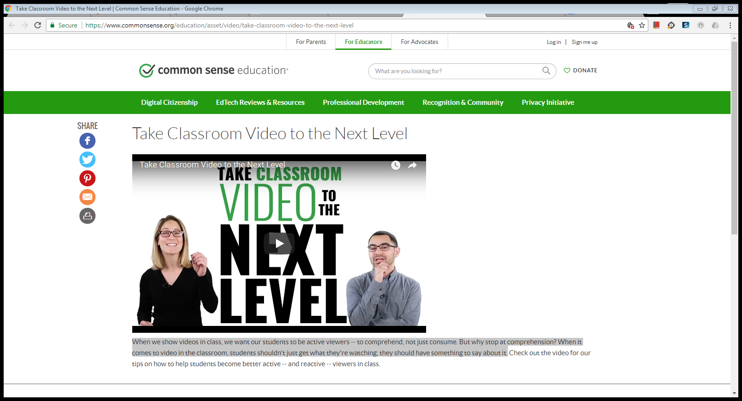](https://www.commonsense.org/education/asset/video/take-classroom-video-to-the-next-level)

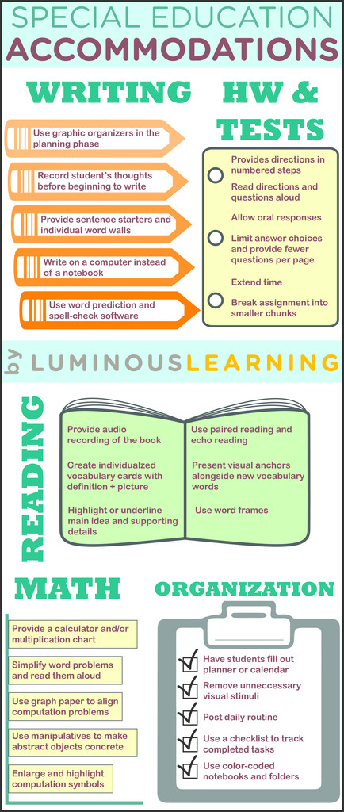

**Women in History Month**



The National Women’s History Project is excited to announce the theme for

National Women’s History 2018:

**NEVERTHELESS SHE PERSISTED:**

**Honoring Women Who Fight All Forms**

**of Discrimination Against Women**

The 2018 National Women’s History theme presents the opportunity to honor women who have shaped America’s history and its future through their tireless commitment to ending discrimination against women and girls. Through this theme we celebrate women fighting not only against sexism, but also against the many intersecting forms of discrimination faced by American women including discrimination based on race and ethnicity, class, disability, sexual orientation, veteran status, and many other categories.

From spearheading legislation against segregation to leading the reproductive justice movement, our 2018 honorees are dismantling the structural, cultural, and legal forms of discrimination that for too long have plagued American women.

Nevertheless She Persisted: This phrase was born in February 2017 when Senator Elizabeth Warren, D-MA, was silenced during Jeff Sessions’ confirmation hearing for Attorney General. At the time, Warren was reading an opposition letter penned by Coretta Scott King (a past NWHP honoree) in 1986. Referring to the incident, Senate Majority Leader Mitch McConnell, R-KY, later said “Senator Warren was giving a lengthy speech. She had appeared to violate the rule. She was warned. She was given an explanation. Nevertheless she persisted.” Feminists immediately adopted the phrase in hashtags and memes to refer to any strong women who refuse to be silenced.

Fighting all forms of discrimination against women takes persistence. The 2018 honorees have all gotten the message to stop, either directly or indirectly, yet they have all continued to fight and succeeded in bringing positive change to the lives of diverse American women.

**Honorees**

<http://www.nwhp.org/2018-theme-honorees/>

**Women in History Resources**

**Scholastic**

<https://www.scholastic.com/teachers/collections/teaching-content/womens-history-month-collection-teaching-resources/>

**TeacherVision**

<https://www.teachervision.com/top-15-womens-history-month-activities>

**The Teachers Guide**

<http://www.theteachersguide.com/womenshistorymonth.htm>

**Read Write Think**

<http://www.readwritethink.org/classroom-resources/calendar-activities/march-national-women-history-20452.html>

**Lesson Plans Page**

<http://lessonplanspage.com/womenshistorymonth-htm/>



**Cultivating a Love of Reading in the Digital Age**

<https://tinyurl.com/yauk4awd>

Four tips for taking advantage of apps and other tools to encourage students to read.

Do your students turn the pages of a book or swipe the screen of a tablet as they read a new story? When children scroll through a blog post like the one you’re reading, how do they know when to pause, click, share, or talk about what they’ve read?

Today’s readers are diving into text in ways we simply couldn’t imagine a decade or two ago. They navigate a new world of print and digital reading material, and our work as educators is to prepare them to grow and shine as readers.

**4 TIPS FOR USING TECHNOLOGY IN READING INSTRUCTION**

1. Learn about their interests to give them a choice in what they read: Students have interests big and small, and giving them a choice in the texts they read can help them explore current interests and learn about new things.

You can poll the class using a tool like [**Kahoot**](https://kahoot.it/) to gauge student interest as you build a classroom library, or use virtual exit slips to get a feel for topics students would like to learn more about. Using this information, you can help guide students toward high-quality books of interest or give them the time and space to explore your classroom or school library.

2. Provide access to a wide variety of texts: With a digital device in their hand, it’s easier than ever for students to search for an article, blog post, or ebook on a topic of interest. Helping them grow to be curators of high-quality reading material is important.

Students who have the world at their fingertips can benefit from guidance as they search for new reading materials. You might introduce them to the reading recommendations in a tool like [**MoxieReader**](http://www.moxiereader.com/)as they search for a new book, or incorporate weekly book shares into your schedule utilizing a tool like [**Flipgrid**](https://info.flipgrid.com/).

3. Find mentor readers to inspire them: We often turn to mentor texts to help students grow as writers by learning from strong examples from different authors. Students need mentors as readers as well. They may have people in their lives who share their experience as readers and love for different genres, but you can try to provide them with mentors.

A [**Google Hangout**](https://hangouts.google.com/) or [**Skype**](https://education.microsoft.com/skype-in-the-classroom/overview) call with a fellow book lover can help students value lifelong reading habits. If you have a friend who is a literature professor, or if there are alumni of your school with a passion for reading mystery books or another genre your students show an interest in, you can set up a video conference and have them come into your class virtually to share their love of reading.

4. Foster a community of supportive and encouraging fellow readers: Students who are surrounded with readers who are passionate about reading online news articles or listening to picture books being read aloud can view themselves as members of a reading community.

You might read a print book to your class and pause for a backchannel discussion using a tool like [**TodaysMeet**](https://todaysmeet.com/). Set up a backchannel room and have students, working in pairs, join the room. You can give them a prompt before or during the reading and have them discuss it with their partners before typing in their single agreed-upon response. This way students can practice both talking to the person next to them face-to-face and participating in an online space to comment about a book.

Alternatively, your reading community might extend outside of the walls of your classroom, leveraging the power of social media to tweet and share reading experiences. Many authors can be found on [**Twitter**](https://twitter.com/), and you or your students can post tweets that tag those authors. If your students pose a question for an author, they’re not guaranteed a response, but they will be practicing a range of skills as they tweet.

As you work to combine both print and digital reading experiences, you are preparing students to navigate a new world as readers. This is powerful, important work that crosses grade levels and content areas.

SOME THINGS HAVEN’T CHANGED

Even in a world with all this technology, it’s still important to allow time for reading in class. Although carving out time in our days is easier said than done, think about the moments in your day when your students are reading independently. Is it just the right amount of time, or not enough? Do students have time to peruse and choose what they read?

Setting aside time on the schedule shows students you value their reading lives and encourages them to spend time in new books and old favorites.

The tips above are adapted from Taming the Wild Text: Literacy Strategies for Today’s Reader.

ns with implementation and how schools plan to strategically scale OER.

In the words of Simon Sinek, if you “start with the why” when thinking about #GoOpen, the answer is easy:

“To provide equitable access of educational materials that are modifiable and shareable no matter the zip code of each school.”

However, the how and the what can be tricky when thinking about scaling OER in your school or district. With that said, I would like to reignite the passion in anybody who reads this article to begin generating excitement around OER.

Here are five recommended steps to getting started.

1. **Assemble your crew.**

Scaling OER requires a dedicated team of educators, instructional leaders, librarians, and technology leaders. In addition to these members, I strongly encourage you to seek feedback from students, parents, school committee members, etc. To truly scale OER, schools need support from every stakeholder in the educational community.

2. **Find your why.**

Even though I just mentioned that this is the easy part, the nuance will vary for every school. No two schools are alike, and all schools will encounter different hurdles and roadblocks along the way. However, it is important for every school to start with a few attainable, measurable goals when setting out on this journey.

3. **Assess your assets.**

This part of the process is an audit of what you are already doing really well and identifying the gaps in your educational experience. Examine current instructional materials and ask why you are using those and what the cost to the district is. This is not an either/or debate, but rather the opportunity to find the gaps in your instructional materials, to see where you can do better, and to use that information as an entry point for scaling OER.

4. **Set your GPS coordinates.**

Once you have assembled your crew, found your why, and assessed your assets, you will want to work backwards from your goal and develop a roadmap of benchmarks and milestones.

5. **Select the right tools.**

The most common question when planning OER strategy is, “Which tools should we use to find these resources?” Although there is no definitive answer, I recommend OER Commons as a good starting place. It is a comprehensive, dynamic site that provides opportunities to find resources. It’s good to get out there and see what is available, but I also recommend building resources organically within your school.

Regardless of the course you chart with OER, keep in mind that this is not about eliminating textbooks. OER is about providing our students and faculty with high-quality, relevant resources that are modifiable and shareable. This is not intended to wage war on the publishing industry, but rather to support equity and inclusion and ensure that all students, no matter the district they attend, have access to high-quality, relevant educational materials.

**Teach Students To Use Social Media (The Right Way) And The Possibilities Are Endless**



<https://tinyurl.com/ybhhovkv>

CJ Marple wanted to teach his young students how quickly information can spread on the Internet.

So earlier this year, the third-grade science teacher wrote up a tweet with the help of his students, asking for other users to retweet the message, or even reply to the message with their location.

The Kansas teacher says he expected 1,000 or so retweets, but within days the tweet went viral and gained more than 227,000 retweets and 75,000 replies from users all over the world. His students, who are probably a little too young for their own social media accounts, learned a lot that week about the power of social media. If used right, Marple says, "The possibilities are endless."

Teachers have taken to creating Twitter accounts for their classrooms, which they use to post assignments and as a forum for students to tweet questions or thoughts on a specific lesson.

But while introducing social media can help learning, some states have gone as far as issuing guidelines for teachers to keep social media interactions between students and teachers appropriate.

The New York City Department of Education is one example. Its guidelines read:

"In recognition of the public and pervasive nature of social media communications, as well as the fact that in this digital era, the lines between professional and personal endeavors are sometimes blurred ... Professional social media sites that are school-based should be designed to address reasonable instructional, educational, or extra-curricular program matters

DiPilato, an English teacher in New Jersey, opted for using Twitter because she can use a specific hashtag for each of her classes and has created a public archive for her students using that hashtag.

"It's been this great way to quickly share information and model a way for Twitter to be used in a healthy way," says DiPilato.

She says her students have school email accounts where teachers can send announcements or homework, but she posts classroom notes and homework assignments on her Twitter account instead.

"Kids check their Twitter more than their school email," she says.

In addition to keeping her class up-to-date with assignments through Twitter, she is constantly retweeting articles that are relevant to their English class in the hopes of teaching her students how to use Twitter personally and professionally.

**Keyboarding Skills and the Common Core**



If you’re a K-6er trying to incorporate the grade-specific Common Core State Standards (CCSS), you’ve probably noticed an interesting skillset nestled within anchor standard W.CCR.6: keyboarding

Here are the relevant Common Core standards for keyboarding:

•Keyboarding is addressed tangentially–saying students must be able to type *** pages in a single sitting (see CCSS.ELA-Literacy.W.4.6 for example. The ‘pages in a single sitting’ starts in 4th grade and continues through 6th where it’s increased to three–see CCSS.ELA-Literacy.W.6.6)

•By 3rd grade, Common Core also discusses the use of keyboarding to produce work, i.e., CCSS.ELA-Literacy.W.3.6 which specifically mentions

Grade 3: With guidance and support from adults, use technology to produce and publish writing (using keyboarding skills) as well as to interact and collaborate with others.

Grade 4: With some guidance and support from adults, use technology, including the Internet, to produce and publish writing as well as to interact and collaborate with others;

demonstrate sufficient command of keyboarding skills to type a minimum of one page in a single sitting.

Grade 5: With some guidance and support from adults, use technology, including the Internet, to produce and publish writing as well as to interact and collaborate with others; demonstrate sufficient command of keyboarding skills to type a minimum of two pages in a single sitting.

Grade 6: Use technology, including the Internet, to produce and publish writing as well as to interact and collaborate with others; demonstrate sufficient command of keyboarding skills to type a minimum of three pages in a single sitting.

Keyboarding is required in order to take Common Core Standards assessments.

To fulfill these standards will require a level of keyboarding expertise by 4th grade. To type one page in a single sitting in 4th grade means typing approx. 300 words without taking a break. At 25 wpm , for that age group, that’s 14 minutes of straight typing. That’s a lot! But not too much. If 4th graders are slower than 25 wpm, the time commitment of sitting in front of a monitor goes up tremendously. For example, at 15 wpm, they would be typing non-stop for 20 minutes–can they do that?

**How to Clean and Disinfect Your Keyboard and Mouse**

Cold and flu season is upon us. Here's a [CDC Resource](https://www.cdc.gov/flu/pdf/freeresources/updated/cleaning_disinfecting_schools.pdf?ck_subscriber_id=31961198) for teachers, parents, students and here's a [guide about sanitizing](http://www.preventchildhoodinfluenza.org/keep-flu-out-of-school?ck_subscriber_id=31961198) (versus cleaning) your classroom. Remember to clean and disinfect the mouse and keyboard of a computer. [Here's how](https://www.cnet.com/how-to/how-to-clean-and-disinfect-your-keyboard-and-mouse/?ck_subscriber_id=31961198).



**DonorsChoose.org Celebrates Funding of 1 million Educational Projects**

[www.donorschoose.org](http://www.donorschoose.org).

To celebrate the milestone, DonorsChoose.org is matched all donations made by individuals to the 35,000 projects live on the site on Thursday, Jan. 25, 2018.

“These million projects represent a million moments where the public told teachers, ‘We’ve got your back.’ said Charles Best, who was a history teacher in the Bronx when he started the concept while looking for a way to buy copies of “Little House On The Prairie” for his students.

The website is now open to public school teachers in all 50 states. Teachers at 77 percent of all the public schools in the country are said to have created classroom project requests.

Projects are vetted by DonorsChoose.org staff. Donors get a photo of their project in action, thank-yous from the classroom, and a cost report showing how every dollar was spent.

Many teachers get families and friends to donate, but a network of individual donors, corporations and foundations have also gotten into the act, giving more than $625 million to projects reaching 26 million students.

**FREE WEBINAR**



February 2018

Flip Badge This!

**Teaching Students to Love Databases**

Wednesday February 21, 2018 @ 5:00 pm - 6:00 pm EST

Get ready to badge your way out of those boring database lessons! Schools are packed with reluctant database users who would much rather get to work than listen to one more database lesson. Well, here is a way to spice up and personalize database instruction. In this edWebinar, Michelle Luhtala, Library Department Chair at New Canaan High School, CT, and Dr. Brenda Boyer, Teacher Librarian at Kutztown Senior High School in Kutztown, PA, will share the flipped instructional program that Dr. Boyer introduced to her virtual library students. There will be time for questions after the presentation. All librarians are invited to attend this live, interactive session. Register: <https://www.anymeeting.com/AccountManager/RegEv.aspx?PIID=ED53DD89854B3E>



**[](https://www.mentimeter.com/)**

**An online interactive presentation software**

Mentimeter is an easy-to-use presentation software used by more than 8 million people. With Mentimeter you can create fun and interactive presentations. Mentimeter is an easy-to-use tool that makes facilitators and presenters look like stars. No installations or downloads required - and it's free! No limit to the number of interactions or votes on your presentation, use Mentimeter in front of large as well as small audiences. Make your teaching more interactive by letting the students actively participate in lectures through using Mentimeter as a formative assessment tool.





January 28th was “Data Privacy Day”. We need to make more of an effort to make students aware of the implications of the lack of privacy they seem so comfortable with.

So many of us, young and old alike, are increasingly comfortable sharing so much about ourselves online, and opening our homes to devices that listen and watch. Yet these practices make as targets. Targets for astroturfing aimed specifically at people with our likes, interests, and demographics. Targets for bad actors to try and take advantage of in many different ways. Targets for federal, state, and local law enforcement to potentially listen and watch, often because of mistaken assumptions or because of someone we may have associated with (a neighbor, old friend, relation) that may or may not be up to something legally questionable.

As a society, and as educators, we need to help students simply by a little more aware of this. Today's young students are growing up in an unprecedented age of digital technology impact, and society absolutely must be aware and engaged in the dialogue about the implications of these rapid changes. Governments and corporations will only advocate for or consider constraints for the sake of safety when they are compelled to do so through the voices of their constituents and customers. That conversation can't happen if we just don't know, or don't care. [Read more……](http://www.emergingedtech.com/2018/01/data-privacy-day-resources-raise-students-awareness/)

**Facing the Screen Dilemma:**

**Young Children, Technology and Early Education**

The authors of this guide represent three organizations whose missions overlap in a

commitment to the wellbeing of children. We share concerns about the escalating misuse

and overuse of screen technologies in the lives of even the very young.

The rapid influx of new screen devices poses a special challenge for the early childhood community. A child born today will experience wondrous technologies few of us can even imagine. How do we best support children’s growth, development, and learning in a world radically changed by technology?

Arriving at a truly child-centered answer to these questions is complicated by several

factors. The new technologies are exciting and often equated with progress. They are evolving so quickly that our grasp of how to make and operate them has rapidly outpaced our

understanding of the educational, developmental, ethical, and social ramifications of their

design and use. Read more……





<https://www.techrocket.com/>

Tech Rocket Founded by iD Tech, Tech Rocket's free platform allows access to its six Hour of Code classes as well as five other free-of-charge classes. For those looking for a more advanced experience, paid subscriptions range from $19 to $29 per month.



**10 Ways to Motivate Your Child to Learn**

If you want your child to be a stellar student, don't limit learning to the walls of his/her classroom. Although the skills he's learning there are crucial to his intellectual and social growth, your child needs your help to open up the world of ideas. His/her renewed joy in discovery will transfer to his schoolwork, so you'll boost his academic achievement too!

1. Fill your child's world with reading.

2. Encourage him to express his opinion, talk about his feelings, and make choices.

3. Show enthusiasm for your child's interests and encourage her to explore subjects that fascinate her.

4. Provide him with play opportunities that support different kinds of learning styles — from listening and visual learning to sorting and sequencing.

5. Point out the new things you learn with enthusiasm

6. Ask about what he's learning in school, not about his grades or test scores.

7. Help your child organize her school papers and assignments so she feels in control of her work.

8. Celebrate achievements, no matter how small. Completing a book report calls for a special treat; finishing a book allows your child an hour of video games

9. Focus on strengths, encouraging developing talents

10. Turn everyday events into learning opportunities.

Read entire article: <https://tinyurl.com/ydcppk5j>



**STEM Projects with Green Screen**

**Written by Miguel Guhlin**

Take your STEM projects to the next level by adding the use of a green screen. It can be done inexpensively and will really engage your students.

Looking for a fun way to introduce STEM projects to students? Try blending green screens into your STEM projects. Let’s take a quick look at a few ways your students can do that.

What’s Green Screen? Before we jump into green screen projects customized for STEM, let’s review what green screens allow you to do.

A green screen allows you to display video or images of far-away places. At the same time, you can have students in your classroom speak to what is displayed in those images or videos. Think of the local television news weather personality. To get started, you will need a screen solution (e.g. the right shade of butcher paper, a $.99 green tablecloth from Dollar Tree, or green cloth) and one of the apps below. If you have an iOS device, the best app on the market is Green Screen by Do Ink, although you can accomplish even more with Touchcast. (source)

Want to see some practical examples of green screen in the classroom? Visit“[Go Green](https://www.tcea.org/blog/stem-projects-with-green-screen/)” resources page where there are amazing examples. Oh, and don’t forget to follow the @doinktweets folks, who make the best, low-cost green app for iOS devices. [Read more..](https://www.tcea.org/blog/stem-projects-with-green-screen/)

**Microsoft Education**

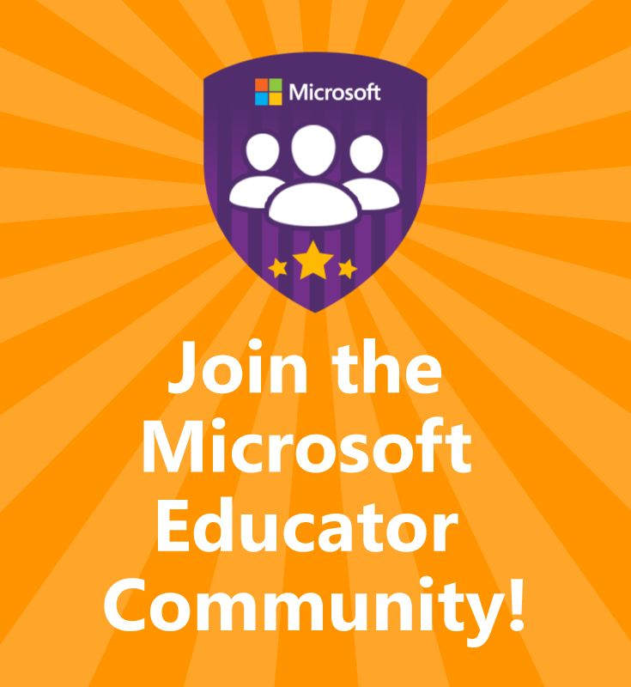

**Join the Educator Community!**

[**https://education.microsoft.com/**](https://education.microsoft.com/)

Connect and collaborate, find training and lessons, and earn badges and certificates on this personalized hub created for educators like you. [LEARN MORE](https://education.microsoft.com/connect-and-share-with-educators/connect-with-other-educators)



<https://doodles.google.com/d4g/>

**Students use their imagination to create a Google Doodle based on what inspires them.**

Does art inspire you? Clouds that look like faces? Sugar? Discovering new galaxies? Artists have looked to the world around them for centuries to gain inspiration. This year’s 10th anniversary of Doodle 4 Google asks students to do the same. The winner’s artwork will be made into an interactive doodle on Google.com as well as loads of scholarships and prizes.

This year’s contest is open for online and mailed entries until March 2, 2018 at 8:00pm PST.

Students can work with any materials they want, but all doodles must be entered using the entry form. Parents and teachers can mail us the completed entry form or submit it online as a .png, or .jpg.

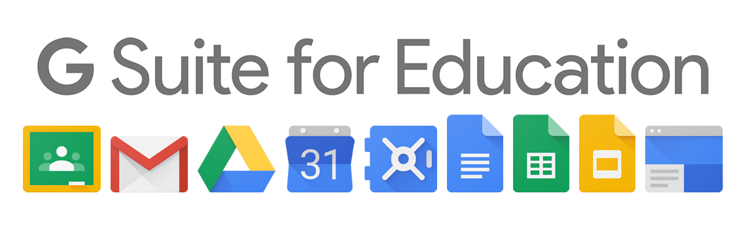

**Help Your Students Become Better Searchers**

Web search can be a remarkable tool for students, and a bit of instruction in how to search for academic sources will help your students become critical thinkers and independent learners.

With the materials on this site, you can help your students become skilled searchers- whether they're just starting out with search, or ready for more advanced training.

With more and more of the world's content online, it is critical that students understand how to effectively use web search to find quality sources appropriate to their task. We've created a series of lessons to help you guide your students to use search meaningfully in their schoolwork and beyond. The literacy lessons help you meet Common Core State Standards and are broken down based on level of expertise in search: Beginner, Intermediate, or Advanced.<https://www.google.com/intl/enus/insidesearch/searcheducation/lessons.htm>

A Google A Day challenges help your students put their search skills to the test, and to get your classroom engaged and excited about using technology to discover the world around them.

**Administrator’s Resource Center**



**How Mobile Apps Can Contribute Effectively**

[**https://www.goodworklabs.com/the-impact-of-mobile-apps-on-education-industry/**](https://www.goodworklabs.com/the-impact-of-mobile-apps-on-education-industry/)

Within the classroom or outside it, using mobile apps helps accomplish a higher degree of precision and efficiency, while making it a fun way of learning or teaching. Making a case for increased penetration of mobile apps into classroom and for virtual learning, we look at some of the key benefits mobile apps have had on the education industry.

1. Range of options – Right from Duolingo for learning languages, Google Earth for geography or even entire course programs on iTunes U, the sheer variety of options available for learner right on his/ her smartphone or tablet is mind boggling.

2. Ease of access of knowledge/ administrative resources – Learning Management Systems and e-learning apps concentrate on providing a visually lasting way of designing educational courses.

3. Learning without boundaries – Be it any or program, there are quite a few apps that have really made it possible for a smartphone user to do any course at any speed at any time. An example is GoodWorkLab’s very own Funzi app, that helps you gain knowledge the fun, easy and convenient way

4. Enable collaboration between students, teachers and parents – Innovative apps like ‘Attendance’ and ‘TeacherKit’ helps teachers keep track of various aspects like performance assessment, grade records or attendance. Apps like Dropbox and Evernote help in seamless collaboration between teachers, students and parents.

5. Improve engagement of student – Science 360 helps students to learn from audio-visual medium and thus keep a long lasting memory of all types of sciences. Watching videos and listening to audio files helps student to retain a science concept better than textbooks. Another example is theuse of eClicker by teachers for polls or real-time feedback from clients.

**[School Mobile App Planning Guide](https://cdn2.hubspot.net/hubfs/296999/School-Mobile-App-Planning-Guide.pdf?t=1516669302562)**

The practical guide to planning and creating a successful school mobile app. You know you want one. Youdefinitely need one. But before youselect a mobile app for your school– just because you think you need one – take heed. Fact is, your school needs one for the simple reason that virtually all your parents, staff and students have phones and other mobile devices, and you are missing golden opportunities to engage them with

an app.

[**School Communication Planning Guide**](http://cdn2.hubspot.net/hubfs/296999/School-Communication-Planning-Guide.pdf)

Using today’s communication channels to engage your entire school community.Reaching your entire school community in today’s digital, mobile world requires a mindset

and the tools to connect how and when your audiences prefer. Your staff, students,

parents and other key stakeholders need to get the information – and you’re at the center

of this critical connection. Websites, school notification systems, mobile apps and social

media form the foundation that is absolutely pivotal to this connection.

**TECHNOLOGY HUMOR**

