To translate messages in Class Dojo on parent accounts follow the steps below.

Step 1. Log into Class Dojo
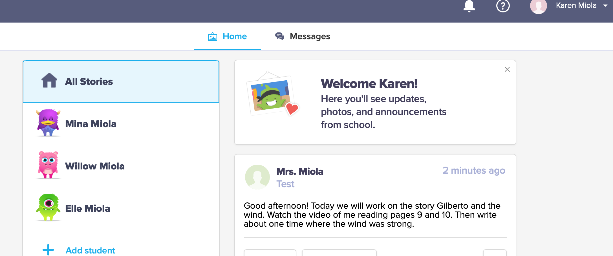

Step 2. At the top on the right side of the screen, click on the arrow to open the drop down menu. Then click on Account Settings.
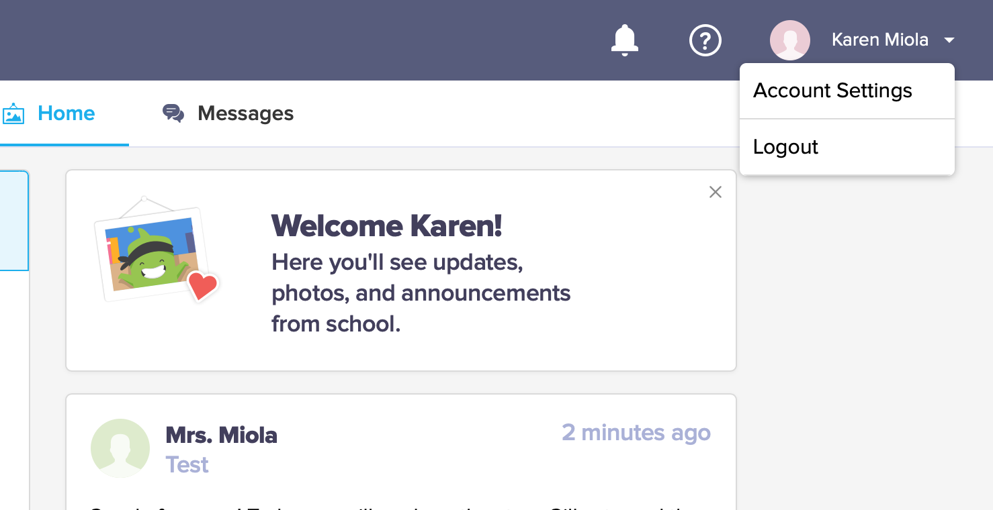

Step 3. Scroll down to Language preference

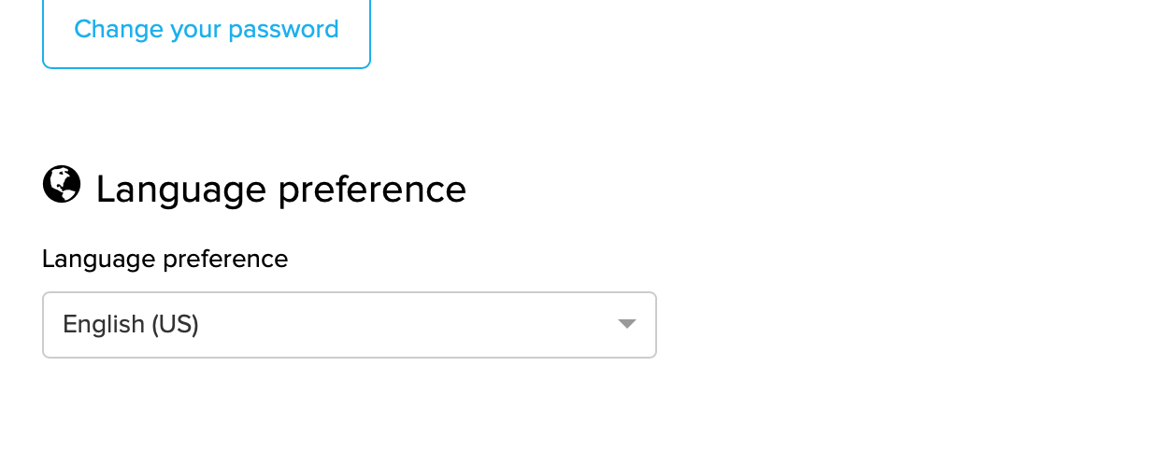
Step 4. Open the Language Choices

Step 5. From the drop down menu, choose your language. Then click Save changes.

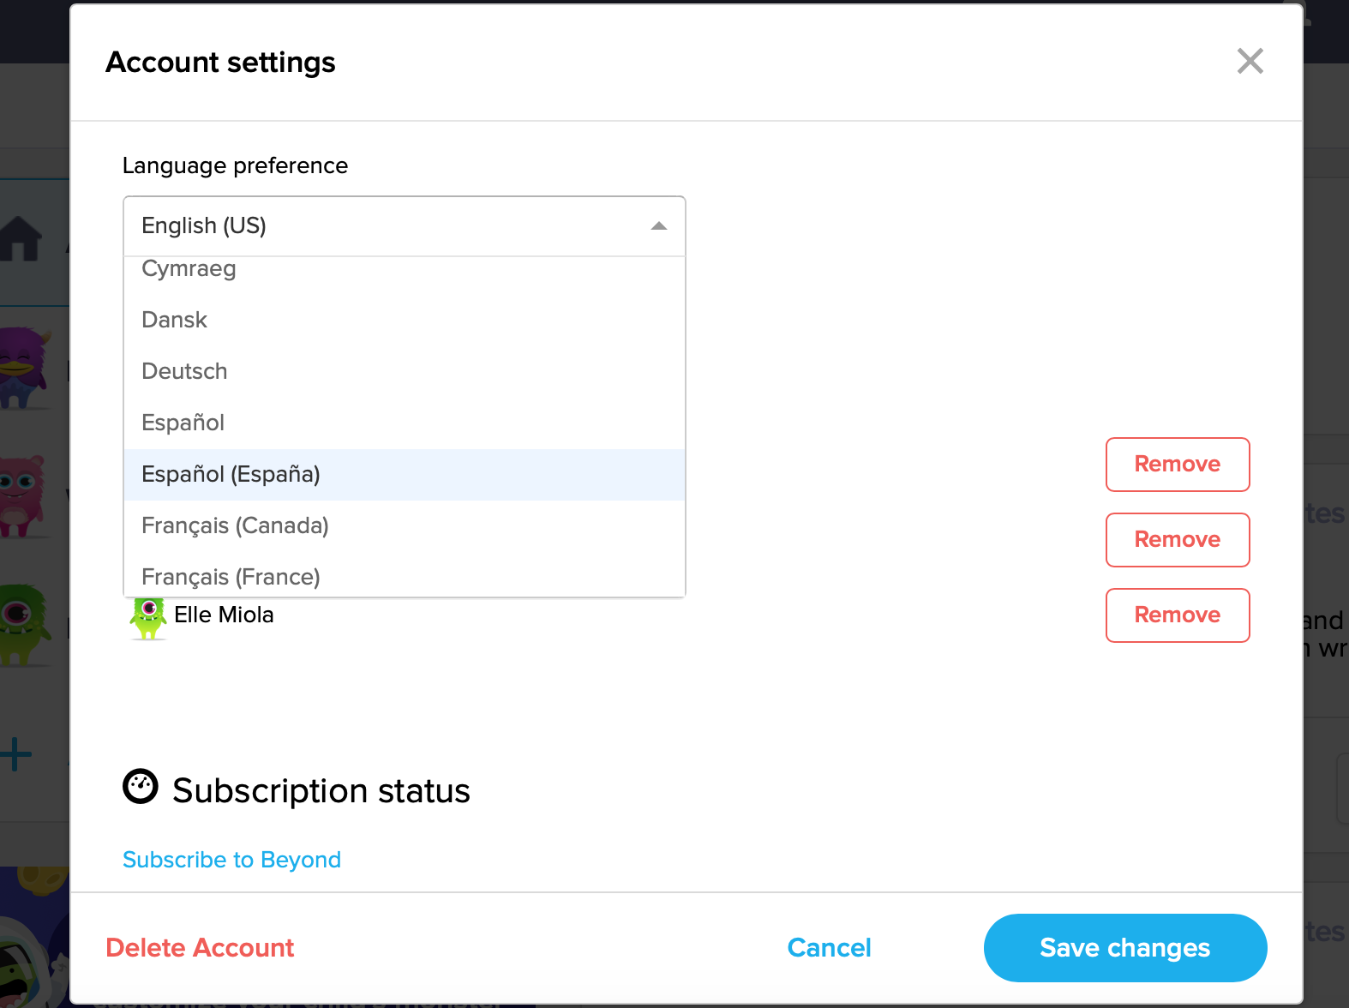

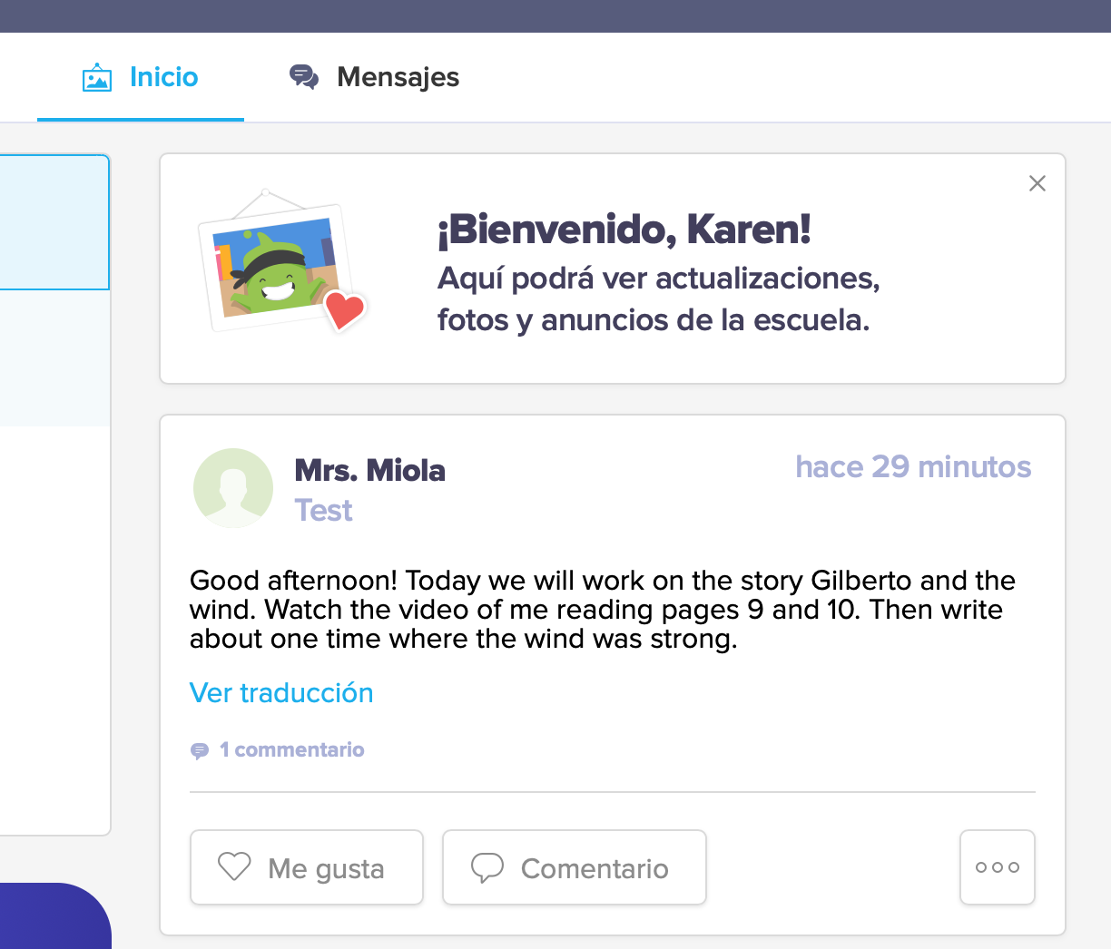
Step 6. When on the homepage any messages from the Dojo app will automatically be in your chosen language.

Step 7. To translate the messages that the teacher writes to the class you can click on the blue writing under the message that will be in the language you choose in Account Settings.
