John Robert Lewis Early Childhood Center
Dr. Cayce J. Cummins, Principal
2023
Sunday | Monday | Tuesday | Wednesday | Thursday | Friday | Saturday
Main Office  973-677-4000  Ext. 51700  123 Cleveland St.  Orange, NJ 07050 | School hours are  8:30 am-3:00 pm |   @JohnLewisECC | JRLECC’s Website   |  | 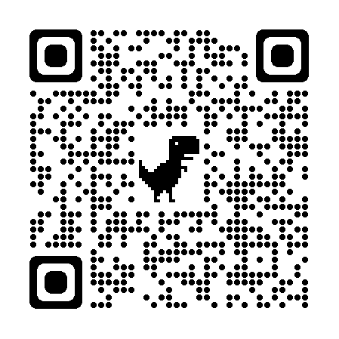  Parent University QR Code
 |  |  |  | 1  OEA Day  Early Student Dismissal  12:30 p.m.  No lunch served today | 2  School Spirit Day  Wear bright colors with denim | 3  Beginning if  Orange Week
4 | 5 | 6 | 7  Public Relations Committee Virtual Meeting  4:00 p.m. | 8 | 9  School Spirit Day  Wear bright colors with denim | 10
11 | 12 | 13 | 14  JRLECC PREK4 MOVING UP CEREMONY  9:00 A.M.  OBOE Public Board Meeting 7:30 p.m. at  Orange Preparatory Academy | 15 | 16  District Closed  Unused Snow Day | 17
18   | 19 District Closed   | 20  Early Student Dismissal  12:30 p.m.  School Lunch will not be served from  6/20-6/23/23. | 21  Early Student Dismissal  12:30 p.m.  4th Annual Bilingual Parent Advisory Council Virtual Meeting  5-6p.m. | 22  Early Student Dismissal  12:30 p.m. | 23  Last Day of School for Students  Early Dismissal  12:30 p.m. | 24
25 | 26 | 27 | 2 | 29 | 30  School Spirit Day  Wear bright colors with denim

