Algebra I (checkpoint examples)

Benchmark 1

1. In a triathlon, Jenny swam for 1 hour, biked for 1.75 hours, and ran for 1 hour. Her average biking speed was 2 times her average running speed, and her average running speed was 8 times her average swimming speed. The total distance of the triathlon was 55.5 kilometers.

Write an equation and solve it to find Jenny’s average swimming speed in kilometers per hour.

1. The You Move It Company (YMI) advertises that the cost to rent a moving truck for one day is $40 plus $1.99 for each mile the truck is driven. The Drive and Move Company (DM) advertises that the cost to rent a moving truck for one day is $60 plus $1.79 for each mile the truck is driven. Alex wants to rent a single truck to use on both Saturday and Sunday on a weekend. For what driving distances should Alex rent the truck from YMI? For what driving distances does it not matter from which company Alex rents the truck? Give a mathematical explanation as to how you arrived at your answer.

Benchmark 2:

1. It is recommended that adults consume at least 1,000 mg of calcium every day. One ounce of whole milk contains 30 mg of calcium, and one ounce of cheddar cheese contains 200 mg of calcium. If a person meets the recommendation by consuming *x* ounces of whole milk and *y* ounces of cheddar cheese, then 

Part A Graph  in the first quadrant of the coordinate plane.

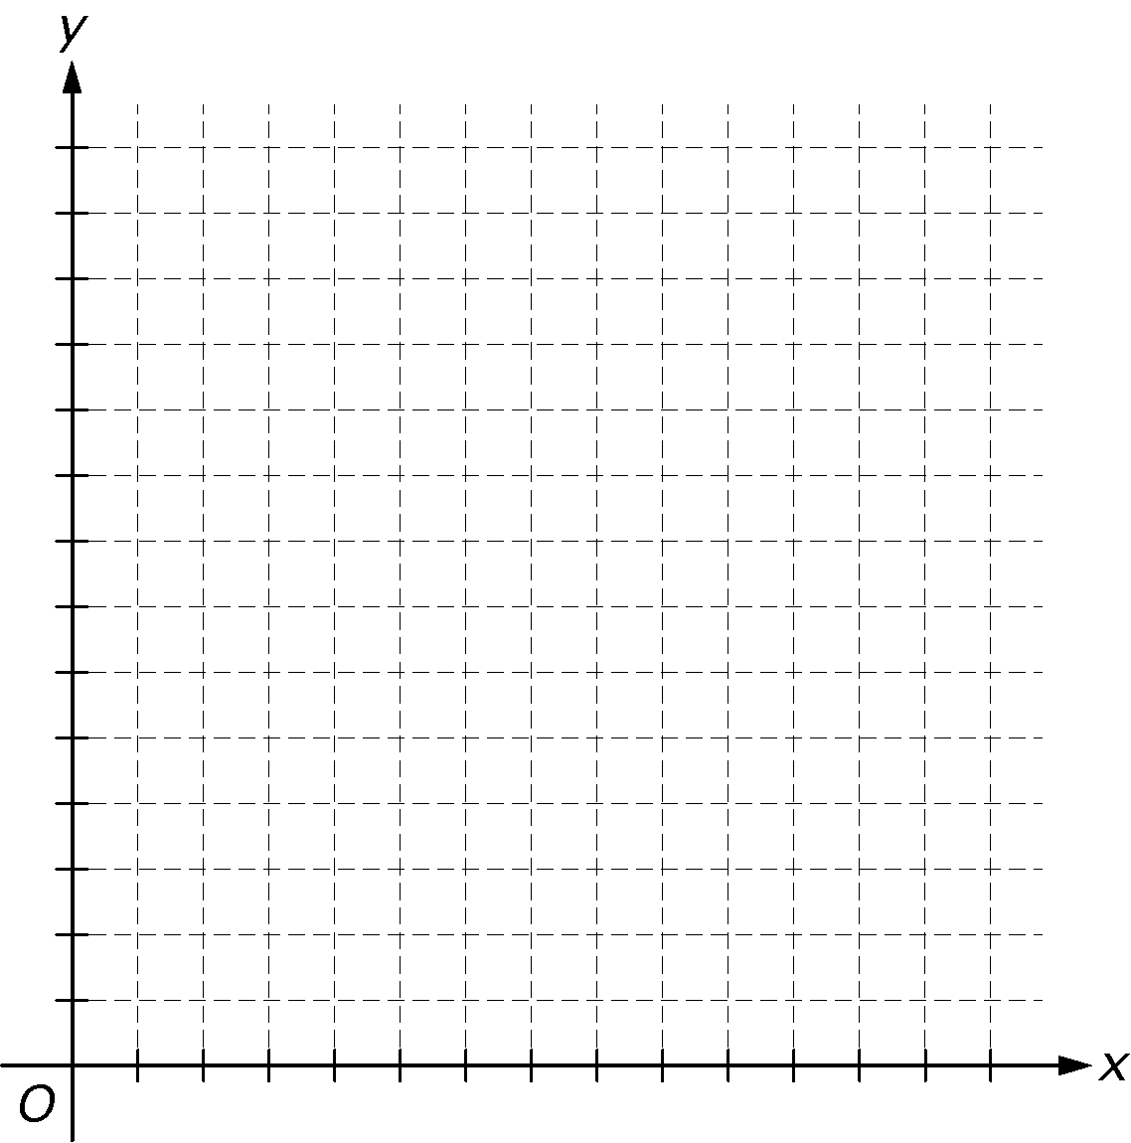

Part B Give three different amounts of milk and cheese that a person could consume to meet the recommendation.

1. In New Jersey, the 2009 tuition cost at public universities for each student who lives in state was $17,547. In-state students paid 70% of the tuition amount, and the rest was paid by the state.

Part A Use function notation to express the total amount of tuition paid by the state for all in-state students as a function of the number of in-state students. Explain how any variables used are defined in the context of the problem. Show your work.

Part B In 2009, there were 69,543 in-state students enrolled at public universities in New Jersey. Use your function from Part A to find the total amount of tuition paid, in dollars, by the state for the 69,543 in-state students. Show your work.

Benchmark 3:

1. The half-life of a radioactive substance is the time it takes for a quantity of the substance to decay to half of the initial amount. The half-life of the radioactive gas radon is approximately 3.8 days. The initial amount of radon used in an experiment is 75 grams. If *N* represents the number of grams of radon remaining *t* days after the start of the experiment, write an equation that gives *N* in terms of *t*.
2. A computer store offers customers a protection plan when they buy a computer. When the plan is priced at $50, the store can sell 100 plans every month for a total of $5,000. A research company determines that for every $5 increase in the price of the plan, the store will sell 3 fewer plans per month.

Part A: Write an expression for the price, in dollars, of a plan if the manager implements *x* $5 price increases.

Part B: Write an expression for the number of plans the store will sell if the manager implements *x* $5 price increases.

Part C: Write an expression for the total, in dollars, the store will receive from the sale of protection plans if the manager implements *x* $5 price increases. Write the expression in standard form.

Part D: Write an inequality that can be used to find *x*, the number of $5 price increases that the manager should implement to receive a total of at least $7,000 per month from the sale of protection plans.

Benchmark 4

1. On a windy morning, a hot air balloon starts ascending and flying away from the top of a hill. The altitude, *h*, in feet, of the balloon *x* hours after starting its ascent from the hill can be modeled by the function 

Part A: Sketch a graph of the function. Provide scales and units on the axes.

1. 

Part B: Identify the *x*- and *y*-intercepts and explain their meaning in context.

Part C: When does the balloon reach its maximum altitude, and what is the maximum altitude obtained?

2



The figure above represents a television screen with a picture-in-picture functionality that displays two channels at the same time on the same screen, with one channel displayed in a smaller rectangle in the top right corner. The length of the television screen is  times the width.

Part A: Write a function,  that represents the area, in square inches, of the television screen with a width of *w* inches.

Part B: The length of the smaller rectangle is  the length of the television screen, and the width is  the width of the television screen. Write a function,  that represents the area, in square inches, of the smaller rectangle for a television screen with a width of *w* inches.

Part C: The area of the smaller rectangle is what percent of the area of the television screen?