4th Grade Mathematics
Fractions and Fraction Applications
Curriculum Map March 10th – April 18th

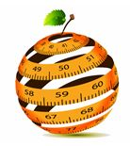

ORANGE PUBLIC SCHOOLS
OFFICE OF CURRICULUM AND INSTRUCTION
OFFICE OF MATHEMATICS

Table of Contents
I. | Unit Overview | p. 2
II. | Important Dates | p. 6
III. | Unit 4 Common Core Standards | p. 7
IV. | Connections to Mathematical Practices | p. 9
V. | Review Content | p. 10
VI. | Visual Vocabulary | p. 39
VII. | Potentials Misconceptions | p. 45
VIII. | New Content | p. 49
IX. | Assessment & Performance Tasks | p. 93
X. | Extensions and Sources | p. 114

Unit Overview
4th Grade
Do Now Standards
4.OA.1-3
4.NBT.4, 5 & 6
Review Standards
4.NF.1
4.NF.2
4.NF.3 a-d
New Content
Fractions and Fraction Applications
4.NF.4
4.NF.5
4.NF.6
4.MD.2
In this unit, students will ….
NUMBERS AND OPERATIONS-FRACTIONS
- Calculate equivalent fractions.
- Draw a fraction model to identify equivalent fractions.
- Explain why multiplying a fraction by an equivalent form of 1 (2/2, 3/3, etc) results in an equivalent fraction.
- Compare and order two fractions with unlike numerators and denominators by creating common denominators or common numerators.
- Compare and order two fractions with unlike numerators and denominators by comparing them to benchmark fractions.
- Explain that comparisons between two fractions are only valid when referring to the same whole.
- Record comparisons between fractions with less than, greater than, or equal to symbols.
- Justify comparison between two fractions using a visual fraction model.
- Explain adding fractions as joining parts of the same whole.
- Explain subtracting fractions as separating parts of the same whole.
- Rewrite a fraction into a sum of smaller fractions with the same denominator.
- Write each decomposition as an equation.
- Explain why rewriting a fraction is equivalent to the original fraction by using a visual
fraction model.
- Add mixed numbers with like denominators using properties of operations, equivalent
fractions, and the relationship between addition and subtraction.
- Subtract mixed numbers with like denominators using properties of operations, equivalent fractions, and the relationship between addition and subtraction.
- Convert mixed numbers to improper fractions to add and subtract fractions with like denominators.
- Identify the operation needed to solve a word problem.
Solve word problems that involve addition and subtraction of fractions with like denominators referring to the same whole.
- Draw visual fraction models or create equations to representing word problems.
Identify the relationship between repeated addition and multiplication.
- Generate multiples of the fraction 1/b.
Multiply a fraction by a whole number by decomposing the fraction as the numerator multiplied by the unit fraction of its denominator.
- Create a numeric expression from a word problem involving the multiplication of a whole number and a fraction.
Solve word problems involving the multiplication of whole numbers and fractions.
- Identify between what two whole numbers the solution lies.
- Convert fractions with a denominator of 10 to an equivalent fraction with a denominator
of 100.
- Add two fractions with denominators of 10 and 100.
- Convert fractions with denominators of 10 and 100 to decimals.
- Locate decimals on a number line.
- Describe lengths in decimal form.
MEASUREMENT & DATA
- Identify the operation(s) needed to solve a word problem.
- Solve word problems involving simple fractions and decimals.
- Solve word problems involving distances, intervals of time, liquid volumes, masses of objects, and money.
- Convert larger unit measurements to smaller unit measurements in order to solve word problems.
- Construct diagrams such as line diagrams to show conversions in measurement

Essential Questions
Numbers and Operations – Fractions
- How can equivalent fractions be identified?
- How are fractions used in problem-solving situations?
- How can fraction represent parts of a set?
- How can I add and subtract fractions of a given set?
- How can I find equivalent fractions?
- How can I represent fractions in different ways?
- How can improper fractions and mixed numbers be used interchangeably?
- How can you use fractions to solve addition and subtraction problems?
- How do we add fractions with like denominators?
- How do we apply our understanding of fractions in everyday life?
- What do the parts of a fraction tell about its numerator and denominator?
- What happens to the denominator when I add fractions with like denominators?
- What is a mixed number and how can it be represented?
- What is an improper fraction and how can it be represented?
- What is the relationship between a mixed number and an improper fraction?
- Why does the denominator remain the same when I add fractions with like denominators?
- Why is it important to identify, label, and compare fractions (halves, thirds, fourths, sixths, eighths, tenths) as representations of equal parts of a whole or of a set?
- How can I model the multiplication of a whole number by a fraction?
- How can I multiply a set by a fraction?
- How can I multiply a whole number by a fraction?
- How can I represent multiplication of a whole number?
- How can we use fractions to help us solve problems?
- How can we write equations to represent our answers when solving word problems?
- How do we determine a fractional value when given the whole number?
- How does the number of equal pieces affect the fraction name?
- How is multiplication of fractions similar to repeated addition of fraction?
- What do the numbers (terms) in a fraction represent?
- What does it mean to take a fractional portion of a whole number?
- What is the relationship between the size of the denominator and the size of each fractional piece (i.e. the numerator)?
- What strategies can be used for finding products when multiplying a whole number by a fraction?
- Which problem solving strategies can we use to solve this problem?

Measurement and Data
- Why does “what” we measure influence “how” we measure?
- What operations could you use to calculate the area and the perimeter of a rectangle?
- How are the area and perimeter of a rectangle related?
- Why does multiplying a rectangle’s length by its width give you its area?
- How can you determine the lengths of all the sides of a rectangle if you just know the length of one side and its area?
- Why do we measure perimeter with linear units and area with square units?
- Describe the relationship between kilograms and grams.
- Why would you want to convert centimeters to meters when measuring?

Important Dates and Calendar
Week of … | Monday |  | Tuesday | Wednesday |  | Thursday | Friday
3/10
3/17 | REVIEW CONTENT
3/24
3/31
4/7 | NEW CONTENT
4/14
4/21 | NO SCHOOL – SPRING BREAK
IMPORTANT DATES
Week of April 7th |  | SGO POST ASSESSMENT  UNIT 4 Check Up
Week of April 28th |  | 7th /8th Grade NJASK
Week of May 5th |  | 5th /6th Grade NJASK
Week of May 12th |  | 3rd/4th Grade NJASK

Common Core Standards
Unit 4
REVIEW CONTENT
4.NF.1 | Explain why a fraction a/b is equivalent to a fraction (n × a)/(n × b)  by using visual fraction models, with attention to how the number and  size of the parts differ even though the two fractions themselves are  the same size. Use this principle to recognize and generate equivalent fractions.
4.NF.2 | Compare two fractions with different numerators and different denominators, e.g., by creating common denominators or numerators, or by comparing to a benchmark fraction such as 1/2. Recognize that comparisons are valid only when the two fractions refer to the same whole. Record the results of comparisons with symbols >, =, or <, and justify the conclusions, e.g., by using a visual fraction model.
4.NF.3 a-d | 3. Understand a fraction a/b with a > 1 as a sum of fractions 1/b.  a. Understand addition and subtraction of fractions as joining and separating parts referring to the same whole.  b. Decompose a fraction into a sum of fractions with the same denominator in more than one way, recording each decomposition by an equation. Justify decompositions, e.g., by using a visual fraction model. Examples: 3/8 = 1/8 + 1/8 + 1/8 ; 3/8 = 1/8 + 2/8 ; 2 1/8 = 1 + 1 + 1/8 = 8/8 + 8/8 + 1/8.  c. Add and subtract mixed numbers with like denominators, e.g., by replacing each mixed number with an equivalent fraction, and/or by using properties of operations and the relationship between addition and subtraction.  d. Solve word problems involving addition and subtraction of fractions referring to the same whole and having like denominators, e.g., by using visual fraction models and equations to represent the problem.
 | NEW CONTENT
4.NF.4 | 4. Apply and extend previous understandings of multiplication to multiply a fraction by a whole number.  a. Understand a fraction a/b as a multiple of 1/b. For example, use a visual fraction model to represent 5/4 as the product 5 × (1/4), recording the conclusion by the equation 5/4 = 5 × (1/4).  b. Understand a multiple of a/b as a multiple of 1/b, and use this understanding to multiply a fraction by a whole number. For example, use a visual fraction model to express 3 × (2/5) as 6 × (1/5), recognizing this product as 6/5. (In general, n × (a/b) = (n × a)/b.)  c. Solve word problems involving multiplication of a fraction by a whole number, e.g., by using visual fraction models and equations to represent the problem. For example, if each person at a party will eat 3/8 of a pound of roast beef, and there will be 5 people at the party, how many pounds of roast beef will be needed? Between what two whole numbers does your answer lie?
4.NF.5 | 5. Express a fraction with denominator 10 as an equivalent fraction with denominator 100, and use this technique to add two fractions with respective denominators 10 and 100.4 For example, express 3/10 as 30/100, and add 3/10 + 4/100 = 34/100.
4.NF.6 | 6. Use decimal notation for fractions with denominators 10 or 100. For example, rewrite 0.62 as 62/100; describe a length as 0.62 meters; locate 0.62 on a number line diagram.
4.MD.2 | intervals of time, liquid volumes, masses of objects, and money, including problems involving simple fractions or decimals, and problems that require expressing measurements given in a larger unit in terms of a smaller unit. Represent measurement quantities using diagrams such as number line diagrams that feature a measurement scale.
Connections to the Mathematical Practices
1 | Make sense of problems and persevere in solving them
1 | Students solve problems by applying their understanding of operations with whole numbers, decimals, and fractions including mixed numbers. They solve problems related to volume and measurement conversions. Students seek the meaning of a problem and look for efficient ways to represent and solve it. They may check their thinking by asking themselves, “What is the most efficient way to solve the problem?”, “Does this make sense?”, and “Can I solve the problem in a different way?”
2 | Reason abstractly and quantitatively
2 | Fifth graders should recognize that a number represents a specific quantity. They connect quantities to written symbols and create a logical representation of the problem at hand, considering both the appropriate units involved and the meaning of quantities. They extend this understanding from whole numbers to their work with fractions and decimals. Students write simple expressions that record calculations with numbers and represent or round numbers using place value concepts.
3 | Construct viable arguments and critique the reasoning of others
3 | In fifth grade, students may construct arguments using concrete referents, such as objects, pictures, and drawings. They explain calculations based upon models and properties of operations and rules that generate patterns. They demonstrate and explain the relationship between volume and multiplication. They refine their mathematical communication skills as they participate in mathematical discussions involving questions like “How did you get that?” and “Why is that true?” They explain their thinking to others and respond to others’ thinking.
4 | Model with mathematics
4 | Students experiment with representing problem situations in multiple ways including numbers, words (mathematical language), drawing pictures, using objects, making a chart, list, or graph, creating equations, etc. Students need opportunities to connect the different representations and explain the connections. They should be able to use all of these representations as needed. Fifth graders should evaluate their results in the context of the situation and whether the results make sense. They also evaluate the utility of models to determine which models are most useful and efficient to solve problems.
5 | Use appropriate tools strategically
5 | Fifth graders consider the available tools (including estimation) when solving a mathematical problem and decide when certain tools might be helpful. For instance, they may use unit cubes to fill a rectangular prism and then use a ruler to measure the dimensions. They use graph paper to accurately create graphs and solve problems or make predictions from real world data.
6 | Attend to precision
6 | Students continue to refine their mathematical communication skills by using clear and precise language in their discussions with others and in their own reasoning. Students use appropriate terminology when referring to expressions, fractions, geometric figures, and coordinate grids. They are careful about specifying units of measure and state the meaning of the symbols they choose. For instance, when figuring out the volume of a rectangular prism they record their answers in cubic units.
7 | Look for and make use of structure
7 | In fifth grade, students look closely to discover a pattern or structure. For instance, students use properties of operations as strategies to add, subtract, multiply and divide with whole numbers, fractions, and decimals. They examine numerical patterns and relate them to a rule or a graphical representation.
8 | Look for and express regularity in repeated reasoning
8 | Fifth graders use repeated reasoning to understand algorithms and make generalizations about patterns. Students connect place value and their prior work with operations to understand algorithms to fluently multiply multi-digit numbers and perform all operations with decimals to hundredths. Students explore operations with fractions with visual models and begin to formulate generalizations.

REVIEW CONTENT
Math Lessons and Tasks
4.NF.1-3 Comparing and Ordering Fractions

Students continue to work with fraction strips to compare and order fractions. This lesson builds on the work done with fraction relationships in the previous lesson. Students develop skills in problem solving and reasoning as they make connections between various fractions.
Questions for Students (After students complete the activity sheet below.)
1. What patterns do you notice when you compare fractions?[If the numerator is the same for both fractions, the larger the denominator, the smaller the fraction. If the denominator is the same for both fractions, the larger the numerator, the larger the fraction.]
2. When you order the fraction strips from largest (the "whole") to smallest (1/8s), what do you notice about the relationship between the size of the fraction and the denominator?[As the fractions get smaller, the denominator gets larger. There is an inverse relationship. Students should be reminded that in each case, the numerator is one.]
3. Do you think this relationship always holds true? [Student responses may vary.]
4. Does a similar relationship hold true for fractions where the denominator is some constant number? [There is an opposite relationship. That is, as the numerator increases, so does the size of the fraction.]
Teacher Reflection
- Which students understand that a fraction can be represented as part of a linear region? What activities are appropriate for students who have not yet developed this understanding?
- Which students can describe part of a linear region using fractions? What activities are appropriate for students who have not yet developed this understanding?
- Which students can compare fractions using fraction strips? What activities are appropriate for students who have not yet developed this understanding?
- Which students can order fractions from least to greatest or from greatest to least? What activities are appropriate for students who have not yet developed this understanding?
- What parts of the lesson went smoothly? What parts should be modified for the future?

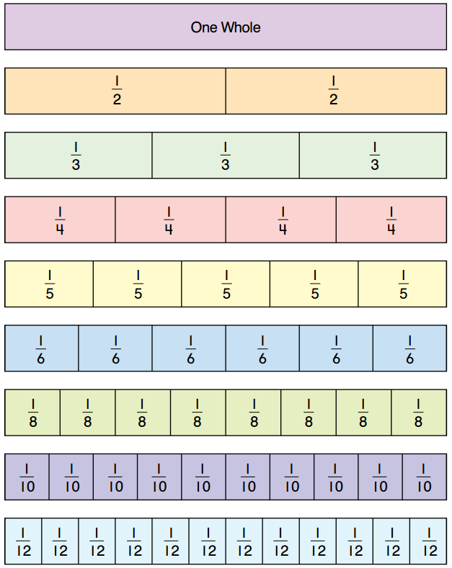
Comparing and Ordering Fractions Activity Sheet

Use your fraction strips to compare the following fractions. Line up each fraction strip to see which fraction has the greatest length. Use >, <, or = to compare each pair of fractions. For example, when comparing 1/2 and 2/4, the fractions should be modeled and lined up as follows:

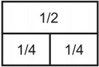

1. | 3/4 | 2/3
2. | 6/8 | 5/6
3. | 2/3 | 3/6
4. | 4/8 | 1/2
5. | 7/8 | 5/6
6. | 1/4 | 2/6
7. | 4/6 | 2/3
8. | 3/8 | 4/6

Use your fraction strips to order the following fractions from least to greatest.

9. 4/6, ⅜, ½

10. 4/8, ⅔, 3/4

11. ⅞, 5/6, 2/3

12. ¾, 5/8, 4/6

13. 6/8, ¾, 4/6

14. 3/8, 2/4, 2/3

15. 4/8, ¾, 4/6
4.NF.1 & 2 Who am I? Puzzles
Introduce the class to puzzle 1: (15 minutes)
Puzzle 1
1/4 1/2 3/4 4/4 5/4
Show the first clue to the puzzle: “I am more than one half.”
Which of these fractions does this clue help us eliminate? ¼ and ½ . Discuss with the class why this clue helps us determine which choices to eliminate.
Show the second clue to the puzzle: “My denominator is larger than my numerator.” How does
this help us get closer to the answer? This will eliminate the fraction 5/4, leaving us ¾ and
4/4.

Show the last clue: “I cannot be written any other way.” The only fraction left that can be
written another way is 4/4, which can be written as 1, so the answer has to be 3/4.

After the class has discussed how to use the clues to solve the puzzles, explain that they will be working on more puzzles in pairs.
Explore (30 minutes)
Students work in pairs or at stations to solve the remaining Fraction Puzzles. As the students are working, observe how the students are solving the puzzles. What are strategies that students use to get started? What clues do they not understand?
When students are finished with the remaining puzzles, students are to attempt to write their own fraction puzzles in their math notebook. Choose any five fractions, and write clues that will help eliminate a fraction or two at a time, but keep the others.
See if other classmates are able to solve their puzzles.
Explain (20 - 40 minutes)
As a class discuss how students were able to solve the puzzles. What clues were most helpful, and what clues were least helpful? Which clues did students need help with?
Share some of the puzzles that the students made.
If time permits, work as a class to solve a few of the puzzles that students have created.

Puzzle  1  Who am I?  ¼ , ½, ¾, 4/4, 5/4  - I am more than one half.  - My denominator is larger than my numerator.  - I cannot be written any other way.  I am _______. | Puzzle  2  Who am I?  2/3 , ¾ , 2/5, 7/10, 6/8  - My numerator is an even number.  - I am greater than one half.  - I am written in simplest form.  - I am _______.
Puzzle  3  Who am I?  2/8, 4/6, 9/12, 3/5, 5/12  - I greater than 1/4.  - My denominator is a multiple of three.  - I can be simplified.  - When I am reduced, my numerator and denominator are less than five.  - I am ______. | Puzzle  4  Who am I?  ½, 5/12, ¼ , 8/10, 2/3  - I am less than one half.  - I am greater than one third.  - My denominator is a multiple of three.  - I am simplified.  I am _______.
Puzzle  5  Who am I?  2/4, 3/9, 1/5, 7/12, 9/10  - I am greater than 1/4.  - I cannot be reduced.  - I am closer to 1 than one half.  I am _______. | Puzzle  6  Who am I?  5/4, 1/5, 4/6, 3/8, 2/10  - I am less than one.  - My denominator is even.  - I can be written in a different way.  - I am another way to say 2/3.  I am _______.
Puzzle  7  Who am I?  6/10, 4/8, 5/9, 1/3, 3/12  - I am greater than one fourth.  - I am not another way to write 1/2.  - I am written in lowest form.  - I am less than one half.  I am _______. | Puzzle  8  Who am I?  7/8, 4/9, 2/10, 9/6, 2/12  - I can be reduced to a simpler fraction.  - I am less than one.  - My denominator is a multiple of three.  - I am closer to one half than I am to zero.  I am _______.

4.NF.3 Kendall’s Candy Company
Introduction (15 minutes)
In today’s activity students build “Special Bars” from different colored pop cubes. Each color will represent a different flavor of candy. The bars come in different sizes depending on the number of candies the buyer wants. The teacher will need to make a bar using 8 total pop cubes prior to the beginning of class.

“Today we are going to pretend to visit a special candy store called Kendall’s Candy Company. At the company they have a very unique candy bar called the Special Bar. This bar is special because the buyer of the bar is able to pick out all the flavors that will be in the bar. This way each bar is different and the buyer can get exactly what they want. As a treat, each person who visits the store receives a free 8 piece Love Bug Bar at the end of their visit.”
To personalize this task, teachers may want to use their name, example: Mr. Smith, Smith Bar.
Students could even use their names when designing a bar of their own.

“Let’s look at the Special Bar that I made on my visit.” Share with student a bar you created that has 8 pieces.
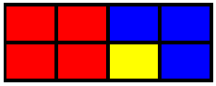

Take a moment to discuss the flavors that are possible. (see possible flavors)
Suggested Questions:
• Which flavor of candy do I have the most of?
• Which flavor of candy do I have the least of?
• How do you know which candy I have the most of?
• How much of my bar is flavored blueberry? Cherry? Banana? Lime? etc.

The answers of the students should be in fraction form. You are not asking how many pieces are certain flavors, but how much of the bar is that flavor. As students tell you the fraction for each flavor, record the fractions on the board.

If I add up the all the fractions 3/8 + 4/8 + 1/8 I will get 8/8 which is the whole candy bar.

Today you are going to build Special Bars of different sizes and record them in you math notebook. First you will build a Special Bar of that has 8 pieces of candy. Then you will record the bar by drawing it in your notebook. After that you will write an equation to show the sizes of your Special Bar. You will repeat the process with Special Bars of different sizes. (2, 3, 4, 5, 6, 8, 10, or 12 pieces)
Explore (20-30 minutes)
Building and Recording Special Bars

Students work on building and recording different sized Special Bars. They first start with a bar that has 8 pieces of candy.
As the students are building and recording the bars, the teacher should be questioning the students work.
• How many (flavor) pieces do you have?
• How many more pieces would you need to complete a bar?
• Which do you have more of? Less of? Equal to?
• What does your equation look like?
• How are you getting the fractions for your equation?
• How does your representation match your Love Bug Bar?
Make sure the representations and equations that are being recorded are correct.

Explain (15 minutes)
Students re-build their favorite Special Bar from the day. Bring the Special Bar and the equations for the bar to a large group meeting. Students share their drawings and discuss the equation that goes along with it.
Other students may want to try figuring out the equation before the presenting student shares it.

Elaborate (10-20 minutes)
Students write a story problem about their Special Bar.

Regan’s Special Bar was 4/10 Cotton Candy, 5/10 Marsh mellow, and 1/10 Orange. Her dog, Izzy, ate all of the cotton candy pieces while she was at school. How much of her Love Bug Bar was remaining?

Students are given part of a bar, and need to complete the rest of the bar.

I have 7/12 of my bar complete with banana and chocolate. I don’t want any more banana or chocolate, but I want two more flavors, what are some of my options?
Evaluation
Formative: As you are working with the students are they able to describe each section of the bar in fraction from? Can they create equations that equal a whole?

Summative: If I had a bar with 3 licorice, 3 cotton candy, 2 apple, and 4 orange pieces, could you draw what the bar looks like. Can you write an equation that represents my Love Bug Bar?

Intervention and Extension
Intervention: Limit the number of types of candy per Special Bar. Start with only two colors, and then continue to add one at a time.
Extension: Build the Mega Special Bar which is only sold for St. Patrick’s Day. The Mega Special Bar has 100 pieces of candy, and can have up to 10 different types of candy.

Possible Flavors for the Colored Connecting Cubes
Red – Cherry
Blue – Blueberry
Light Green – Lime
White – Marshmallow
Brown – Chocolate
Black – Licorice
Yellow – Banana
Pink – Cotton Candy
Dark Green – Apple
Orange - Orange
4.NF.3 Fractions Relay Race



Introduction (15-20 minutes)

Today we are going to get ready for a relay race. Before we run the race we need to make a plan. Each team will have three people on it. Each person on a team has to run in the race, but they do not need to run the same distance. There are certain places during the race where you can hand off the baton to the next runner. You are going to get a chance to plan the distances of each runner on your team before the race begins.

Let’s work together to try to make a plan for a team. Today’s race will have different places that a team can hand off their baton to the next runner.

Draw a line on the board with a start and finish line. Mark 5 locations, equal distance apart, where students can hand off the baton. This will break the track into 6 separate sections. Students may have a difficult time with the concept that there are 5 locations to hand off, but 6 sections to the race. This is a good time to discuss the fact that the distance between the marks is what we are considering and not the marks.

Have students talk with their teammates to determine some possibilities to setting up the race.
Remember that each person doesn’t have to run the same distance.

Share a few of the students’ ideas, and ask what fraction of the race each student will need to run.

S X X F

In this race, the first runner runs 3/6 of the race, the second runner runs 2/6, and the final runner runs 1/6.

Write an equation for each idea. 3/6 + 2/6 + 1/6 = 6/6 or 1 whole

Look for multiple ways to set up the race.

Explore (20-30 minutes)
Students work on planning four different races. For each race the student teams need to find multiple ways to set up each race. They record the distance each runner will run, and then write an equation that will equal one whole.

Explain (15-20 minutes)
Have students share their possibilities for each race and discuss their favorite and the reason why they chose it.

Make the connection between the races and a number line from 0 – 1.
How are these similar?

Elaborate (15 – 20 minutes)
Set up a race outside using cones as hand off positions. Have the students run the race according to their plans.

What are some possibilities if we had only 2 people on a team? 4 people?

Evaluation of Students
Formative:
While students are working, observe them and pose questions to check for their mathematical understanding.

Summative:
Students’ work from the Explore phase can be used as a summative assessment.

Intervention:
If students are having difficulties provide them with fractions manipulatives (fraction bars, fraction tiles) to help them visualize the idea of decomposing a whole unit.

Extension:
If students are in need of an extension have them design a relay race that is 2 laps long so they have to decompose the number 2. You could also have them design a race that is 2 ½ laps long.

Race 1

S F

This race has 6 different sections to run. What are some possibilities that your team can run?

Runner 1 | Runner 2 | Runner 3 | Equation

Which one of your options is your favorite one? Explain why.



Race 2

S F

This race has 4 different sections to run. What are some possibilities that your team can run?

Runner 1 | Runner 2 | Runner 3 | Equation

Which one of your options is your favorite one? Explain why.

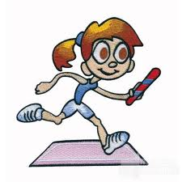
Race 3

S F

This race has 10 different sections to run. What are some possibilities that your team can run?

Runner 1 | Runner 2 | Runner 3 | Equation

Which one of your options is your favorite one? Explain why.


Race 4

S F

This race has 8 different sections to run. What are some possibilities that your team can run?

Runner 1 | Runner 2 | Runner 3 | Equation

Which one of your options is your favorite one? Explain why.

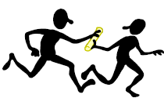
Money in the Piggy (4.NF.A)
Alicia opened her piggy bank and counted the coins inside. Here is what she found:
- 22 pennies
- 5 nickels
- 5 dimes
- 8 quarters

  - How many coins are in Alicia's piggy bank?

  - What fraction of the coins in the piggy bank are dimes?

  - What is the total value of the coins in the piggy bank? Give your answer in cents: for example $2.35 is 235 cents.

  - What fraction of the total value of the coins in the piggy bank is made up of dimes?

Running Laps (4.NF.A)

Cruz and Erica were both getting ready for soccer.
- Cruz ran 1 lap around the school.
- Erica ran 3 laps around the playground.
Erica said,
I ran more laps, so I ran farther.
Cruz said,
4 laps around the school is 1 mile, but it takes 12 laps around the playground to go 1 mile. My laps are much longer, so I ran farther.
Who is right? Draw a picture to help you explain your answer.

Explaining Fraction Equivalence with Pictures (4.NF.1)

- The rectangle below has length 1. What fraction does the shaded part represent?
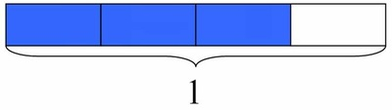
- The rectangle below has the same length as the rectangle above. What fraction does the shaded part represent?
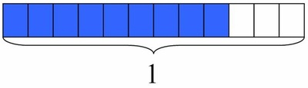
- Use the pictures to explain why the two fractions represented above are equivalent.

Fractions and Rectangles (4.NF.1)

- What fraction of the rectangle below is shaded?
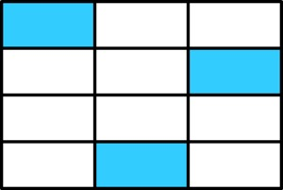
- Laura says that of the rectangle is shaded. Do you think she is correct? Explain why or why not by using the picture.

Doubling Numerators and Denominators (4.NF.2)

- How does the value of a fraction change if you double its numerator? Explain your answer.

- How does the value of a fraction change if you double its denominator? Explain your answer.

Listing Fractions in Increasing Size (4.NF.2)

Order the following fractions from smallest to largest:
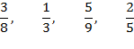

Explain your reasoning.

Using Benchmarks to Compare Fractions (4.NF.2)

Melissa gives her classmates the following explanation for why :
I can compare both and to .
Since and are unit fractions and fifths are smaller than fourths, I know that <
I also know that is the same as , so is bigger than
Therefore .
- Explain each step in Melissa's reasoning. Is she correct?

- Use Melissa's strategy to compare and , this time comparing both fractions with .

- Use Melissa's strategy to compare . Explain which fraction you chose for comparison and why.

Comparing Two Different Pizzas (4.NF.B)

Jessica and some friends have ordered two pizzas. One is a medium sized pizza while the other is a large.
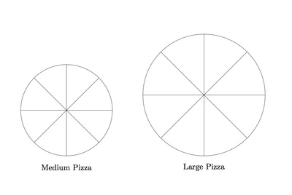
Jessica eats two slices of the medium sized pizza. Has Jessica eaten of the two pizzas? Explain your reasoning, and draw a picture to illustrate your explanation.

Comparing Sums of Unit Fractions (4.NF.3a)

Use <, =, or > to compare the following sums:
- ________

- ________

6y66Making 22 Seventeenths in Different Ways (4.NF.3b)

Which of the following sums are equal to ?

Find another way to write as a sum of fractions.

Writing a Mixed Number as an Equivalent Fraction (4.NF.3b)

Ben wrote a mixed number as the fraction . Here is his work:
(Step 1)

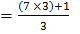 (Step 2)

= (Step 3)

= (Step 4)
Explain what Ben did in each step.

Peaches (4.NF.3b)

Alfredo picked pounds of peaches from the tree in his backyard. He gave pounds to his neighbor Madeleine. How many pounds of peaches does Alfredo have left?

Plastic Building Blocks (4.NF.3b)

Dennis and Cody are building a castle out of plastic building blocks. They will need buckets of blocks for the castle they have in mind. Dennis used to have two full buckets of blocks but lost some and now has buckets. Cody used to have two full buckets of blocks too, but now has buckets. If Dennis and Cody combine their buckets of blocks, will they have enough to build their castle?

Cynthia’s Perfect Punch (4.NF.3b)
Cynthia is making her famous "Perfect Punch" for a party. After looking through the recipe, Cynthia knows that she needs to mix gallons of fruit juice concentrate with gallons of sparkling water.
- Just as she is about to get started she realizes that she only has one 10-gallon container to use for mixing. Will this container be big enough to hold all the ingredients?

- How much punch will this recipe make?

Assessment Check – Fractions
1. | 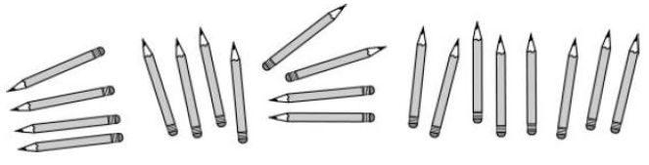  Aisha, Sara, and Brendan have 20 pencils. Aisha says 4 of the pencils are hers. Sara says of the pencils are hers. Brendan says of the pencils belong to him. Explain how they all could be right. Use words or drawings.
2. | Which fraction is closest to Answer this problem without a calculator.
3. | Judy and Gregg are playing a game with fractions. They have to draw their own cards for each fraction. Whoever has the larger fraction wins both cards.  - Draw the fraction card for each fraction below.  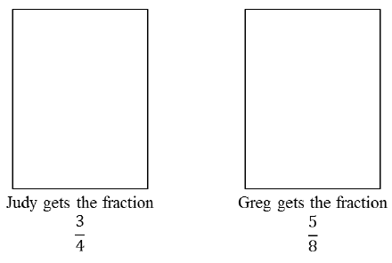  - Explain who wins the round and how you know it.
4. | Decide whether each expression is True or False?  a. 3/8 < ¼ ○ True ○ False  b.1/2 < 3/6 ○ True ○ False  c. 3/5 = 8/10 ○ True ○ False  d. 2/3 = 4/6 ○ True ○ False
5. | Which is larger? 4/6 or 6/9 ?  a. 6/9 because both numbers are greater than numbers in the other fraction. Yes No  b. They are both the same because they each have a 6 in it. Yes No  c. They are both the same because they are equivalent fractions. Yes No  d. 4/6 because there is a smaller difference between numerator and Yes No
6. | A zookeeper made this line plot to show the ages of all the monkeys at a zoo.  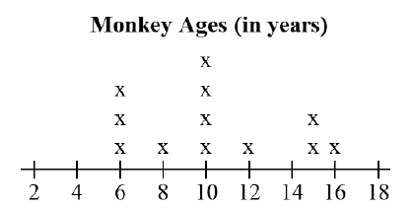  Part A  What fraction of the monkeys at this zoo are eight years old?  Part B  What fraction of all the monkeys at this zoo are not 8 years old?
7. | Judy conducted an experiment. She put a total of 2 1/8 cups of water into an empty container. Then, Judy recorded the amount of water that evaporated from the container each day for four days.  The plot line below shows the amount of water that evaporated from the container on each of the four days.  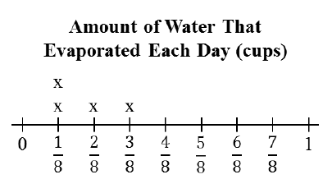  “X” represent 1 day  What mixed number represents the amount of water left in the container at the end of the fourth day?
8. | A builder planned to build houses. Each house will be built on of an acre. How much land would be needed for 7 houses? Show your work.  The builder began with 10 acres of land. After 7 houses were built, how much land was left unused?  Show your work

Vocabulary

Visual Definition
The terms below are for teacher reference only and are not to be memorized by students. Teachers should first present these concepts to students with models and real life examples. Students should understand the concepts involved and be able to recognize and/or use them with words, models, pictures, or numbers.
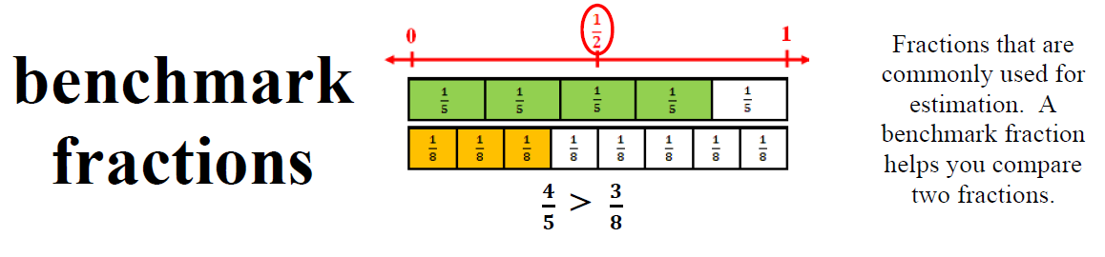
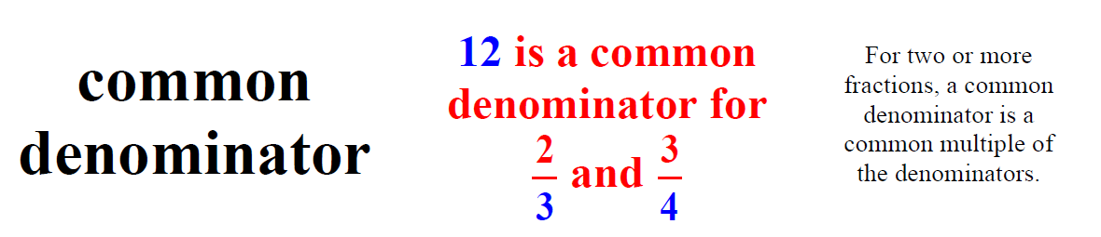
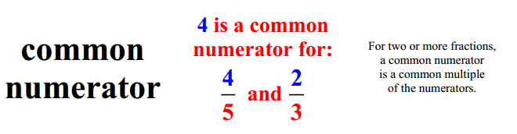
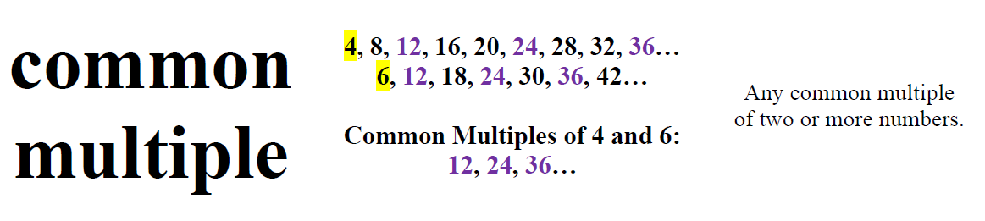
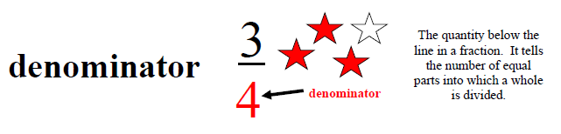
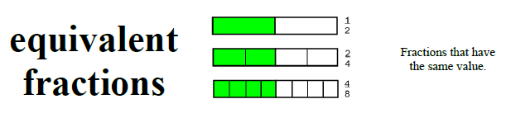
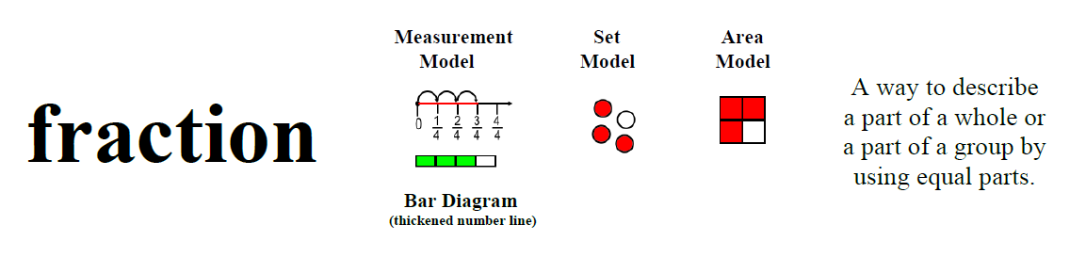
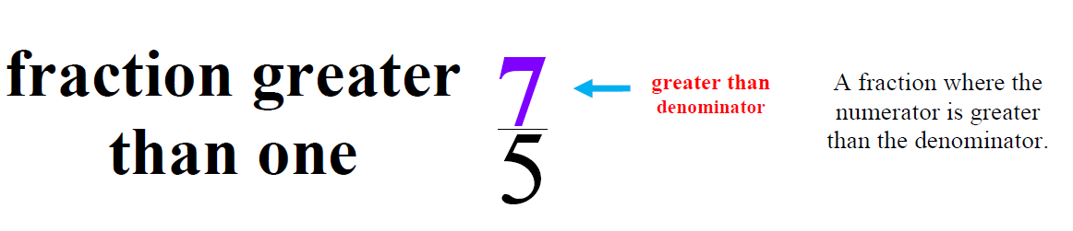
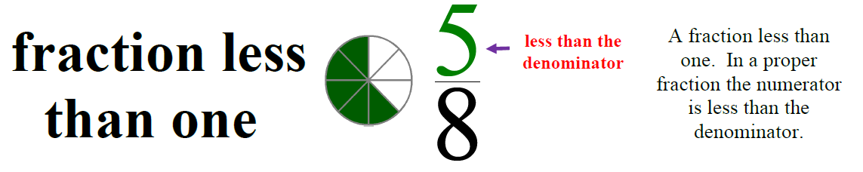
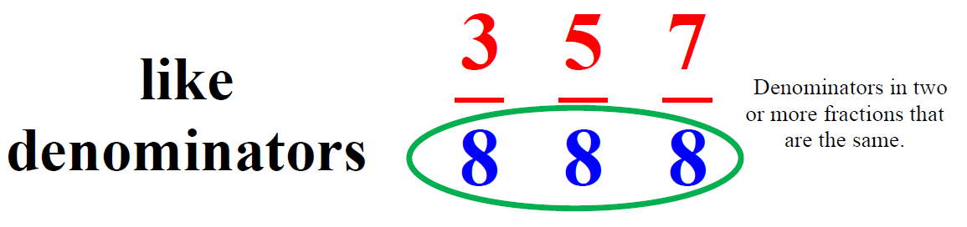
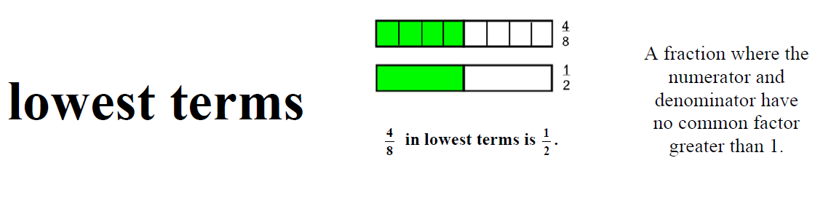
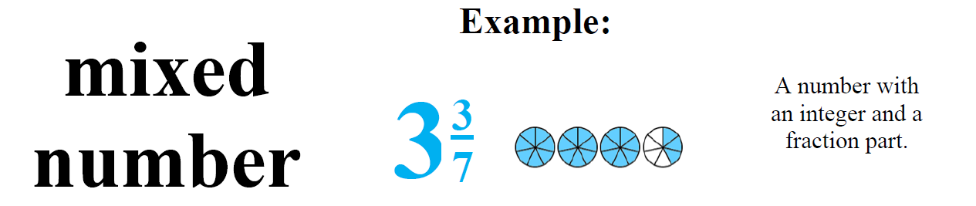
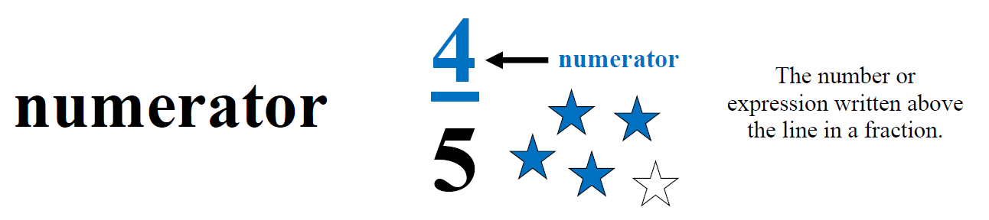
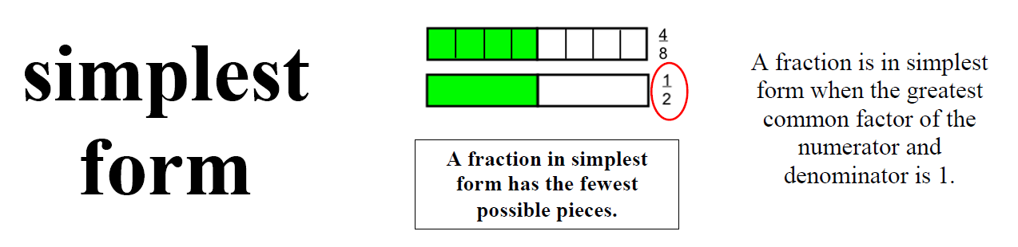
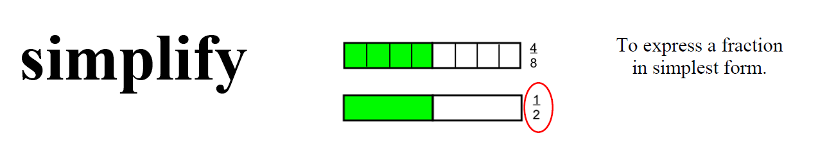
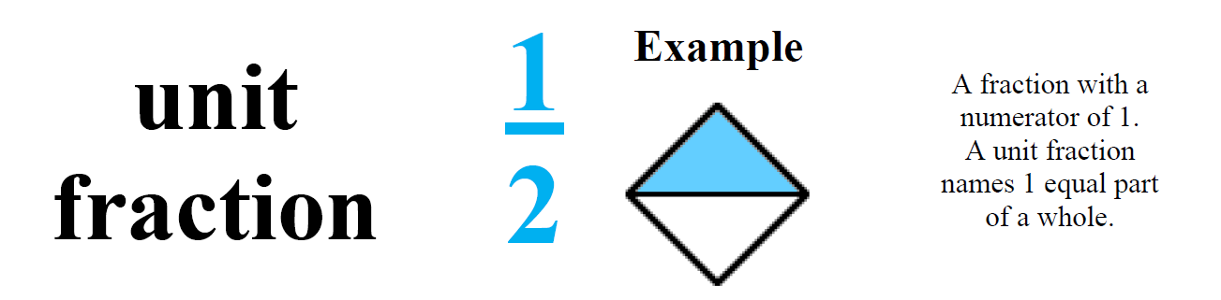
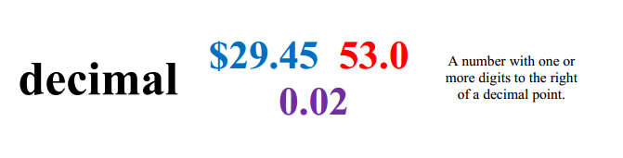
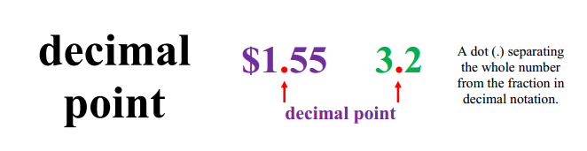
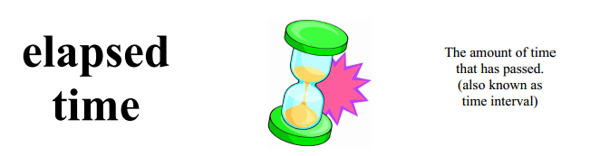
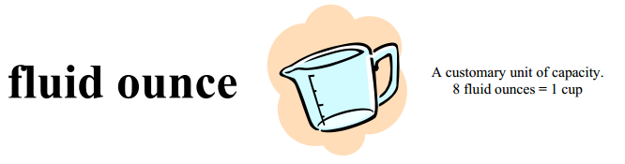
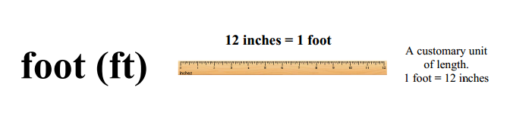
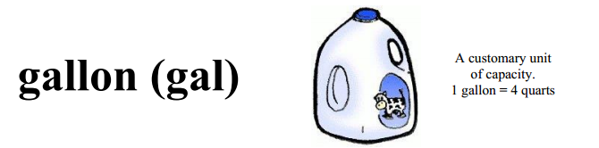
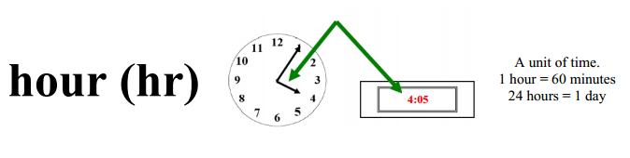
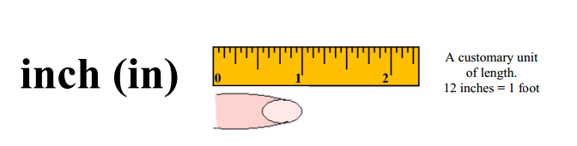
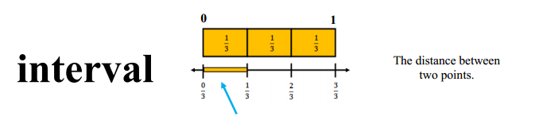
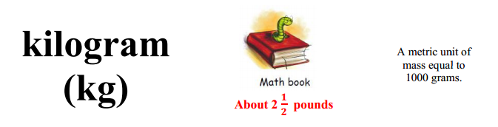
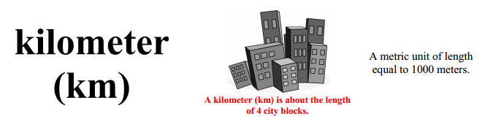
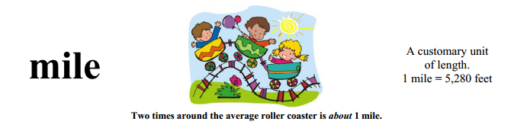
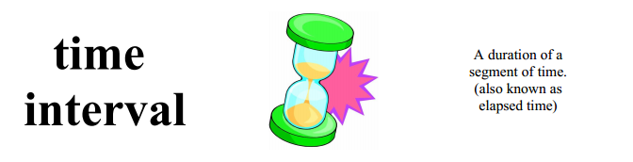

Potential Student Misconceptions
Number and Operations – Fractions
Students do not understand the difference between the numerator and denominator.
Fraction terminology is not intuitive. Have students count by fractions and highlight the relationship between the numerator and denominator. Continually connect the meaning of numerator and denominator to models.

Students believe that the larger the denominator, the larger the piece.
This can result from students incorrectly memorizing “the larger the denominator the smaller the piece.” Rather than simple memorization, have students make sense of this relationship themselves. For example, have students investigate whether they would prefer to eat one-hundredth of a 8-inch pizza or one-fourth of a 8-inch pizza. Have them defend their answer in terms of what you’ve heard other students say, that 100 is more than 4, so one-hundredth must be greater.

Students believe that the numerator alone determines the size of the fraction.
Fractions are a part-to-whole relationship. Have students create models of fractions, and associate the written fraction to the relationship between that part to its whole. Have students confront this relationship using a wide variety of fraction models. Continually connect the vocabulary for fraction names to models.

Students add fractions with unlike denominators by adding numerators together and adding denominators together.
For example, a student might say ½ + ¼ = 2/6 when it really equals ¾. Have students use fraction models such as paper strips to model the problem and to verify their thinking.

Students may use the denominator as the decimal when converting fractions to decimals.
Students need many opportunities with models, e.g., hundred grids, money. Students will then be able to verify their thinking about ½ ; e.g., a student might say ½ = .2 or .20 instead of .5 or .50, however using a model would resolve this misconception.

Students don’t understand that equivalent fractions are different names for the same amount.
Have students use fraction models to identify equivalent fractions and to verify their reasoning.
Measurement & Data
Students may memorize formulas without understanding the reasoning behind them.
Students may simply memorize a formula for area “length times width,” without understanding how to measure length and width. Provide lots of opportunities to measure various objects using metric and standards units.

Students have difficulty interpreting a ruler.
Rulers often label the metric side solely with millimeters, so students don’t always associate 10 millimeters as being equal to one centimeter. Students may not understand that zero (0) is the starting point of measurement on a ruler and that the numbers indicate the distance from the end of the ruler. Discuss the importance of the spaces between the lines on the ruler and the distance that the lines represent.

When making line plots, students may not record each piece of data.
For example, If the data includes 2, 2, 2, 3, 3, 3, 4, the student may just record 2, 3, and 4. Discuss how a line plot is a representation of an entire set of data, and that omitting data will alter the conclusions that can be drawn.

Concrete and Pictorial Representations
Multiple Representations Framework
Equal Partitioning and Unitizing  Using Visual Fraction Models  - Fraction Strips  - Fraction Circles  - Number line | 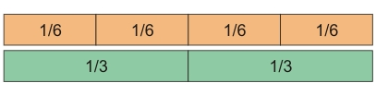  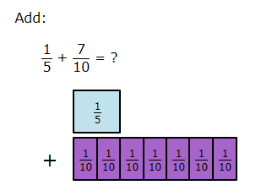  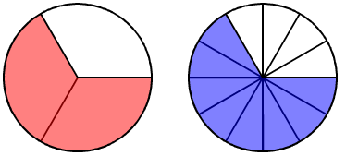  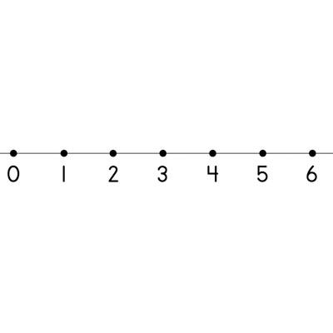
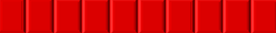  Bar Model | Leticia read 7 ½ books for the read-a-thon. She wants to read 12 books in all. How many more books does she have to read?  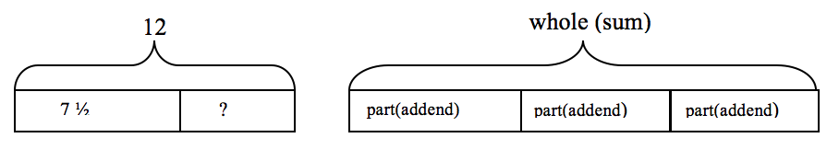  12 - 7 ½ = ? or 7 ½ + ? = 12 so Leticia needs to read 4 ½ more books.
Tangram Puzzle  Choosing each piece of the Tangram set, students are asked identify the size of the pieces based upon  - The original square  - The size of a select piece  - When assigning a value to each piece, for example when the large right triangle is equal to 2. |   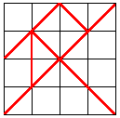
Equivalent Fractions | For example, 2/3 + 5/4 = 8/12 + 15/12 = 23/12. (In general, a/b + c/d = (ad + bc)/bd.)
Benchmark Fractions | 1/2, 1/3, 1/4, 1/5, 1/6. 1/8, 1/10
Abstract Representations
Basic Mathematical Properties | Additive Inverse  Example: 7 + (-7) = 0
Algorithm | In general,  a/b+c/d=(ad+bc)/bd

NEW CONTENT
Lessons and Tasks
4.NF.4
Background: Before assigning the task, students should have had several experiences with finding a fraction of a set. Also, students should have some degree of fluency with multiplication facts with a product of 24 or less. Student solutions to the riddles should include a picture of the beans and an explanation using words and numbers.

Each student will need the following materials:
● “A Bowl of Beans” student recording sheet
● Handful of mixed beans (red kidney beans, pinto beans, black beans, black-eyed peas, etc.) . Naturally other items like linking cubes can be used to replace the food.
● Small paper plates
● Colored pencils or crayons

Task Directions:

Students will follow the directions below from the “A Bowl of Beans” student recording sheet.
You will need a bowl of different kinds of dried beans to solve the riddles below. Draw a picture of your set of beans for each riddle. Explain how you solved each riddle, using words and numbers. Finally, represent your answer with a number sentence (for example: if you have 6 beans and ⅓ are red then write the number sentence ⁶⁄₃ = 6 x ⅓ or 6 x ⅓ = ⁶⁄₃)

Formative Assessment Questions

- What information in the riddle did you need first?
- Is there any missing information in the riddle?
- If you have ___ (i.e., 9) beans in ___ (i.e., 3) equal groups, how many beans are in each group? How many groups do you need? How do you know?
- If we know of the beans are 3 beans, how many beans would be of the beans? How do you know?
- How did you know how many ___ (i.e., red) beans to use?
- How would this set of beans look if there were 12 beans instead of 9 total beans?

Differentiation

Extension
- Ask students to create riddles with at least three types of beans.
- Have students explore equivalent fractions represented in a set (i.e., in a set of 9 beans if 1/3 of the set is red, then 3/9 of the beans are red).
Intervention
- An alternative activity could be used as follows:

Riddle #1

I have 6 beans. One-third of the beans are pinto beans. How many beans are pinto beans?

Riddle #2

I have 8 beans. One-eighth of the beans are black beans. How many beans are black beans?

Riddle #3
I have 12 beans. One-fourth of the beans are red beans. How many beans are red beans?
Name:_________________________________________

A Bowl of Beans

You will need a bowl of different kinds of dried beans to solve the riddles below. Draw a picture of your set of beans for each riddle. Explain how you solved each riddle using words and numbers. Finally, represent your answer with a number sentence (for example: if you have 6 beans and ⅓ are red then write the number sentence ⁶⁄₃ = 6 x ⅓ or 6 x ⅓ = ⁶⁄₃)

Riddle #1
● I have 8 beans.
● of my beans are red.
● The rest are pinto beans.
Show my set of beans.

Riddle #2
● of my beans are red.
● I have 9 beans.
● of my beans are black.
Show my set of beans.

Riddle #3
● of my beans are black-eyed peas.
● of my beans are pinto beans.
● The rest are red.
● I have 12 beans.

Show my set of beans.

Create your own bean riddle below. Show the answer to your riddle on the back of this paper.

4.NF.4 Birthday Cake
Background:
For this activity students will be asked to determine the given number of candles on each piece of birthday cake when given a total number of candles on the cake. All problems assume that the cake pieces will be equal and everyone will always receive the same number of candles. The first part of the assignment provides students with whole to part problems. In other words, the students receive the whole amount in the question but need to produce the part of the whole to determine their answer. In the second part of the task students are given the number of candles on just one piece of cake or one fraction of the cake and have to then determine how many candles were on the entire cake. The second part of the assignment provides students with part to whole problems where they receive a part or fraction in the question but need to produce the whole amount to determine the answer.

Before asking students to work on this task, be sure students are able to:
● Use repeated addition to add fractions with the same denominator.
● Be able to decompose fraction, for example ⁴⁄₄ = ½ + ½ or ¼ + ¾.
● Have a strong understanding that the whole can be any number/size and the fractions always depend on taking a portion of this whole.

MATERIALS
● Paper plates or large circles either cut out or drawn
● Two sided counters, base ten units, or some other small counter
● Birthday Cake student recording sheet.

Task Description

In this task, students will use a pie model to multiply a whole number by a fraction. Students will gain experience solving both part-to-whole and whole-to-part word problems that ask them to multiply a fraction by a whole number or multiply a whole number by a fraction.

Paper plates and counters should be made available for students to act out each of these problems. If paper plates are not available, a large circle drawn on an 11 x 8.5 inch paper will work just as well. Students could also color or draw their candles, or use glue and die cuts.

Students will follow directions below from the Birthday Cake! task sheet.
● Obtain a set of counters and paper plates.
● Work with a partner or small group to make a fraction cake and record it on your task sheet.
● Be ready to articulate your reasoning.

FORMATIVE ASSESSMENT QUESTIONS
● How do you know how many pieces of cake there are?
● Can you write an equivalent fraction for your answer? (for the example above, ¼ = ³⁄₁₂)
● Are the candles evenly distributed or fairly distributed?
● In what other situations do we need to share evenly?

DIFFERENTIATION
Extension
● Once students have completed the task above, this lesson could be extended to use larger numbers of candles and larger fractions.
● Students could solve problems where the numerator is a number other than 1. For example, ⁵⁄₆ of 30.
● Students could also extend this task by exploring how the task would change if you had 2 or 3 cakes rather than just one whole cake.

Intervention
● Students may need to review division and have experiences where they can see the relationship between the two.
● Students may use repeated addition to solve these problems.
● Students may be given cakes already “cut” or drawn in parts to help them realize what the denominator will be.
● Initially, students can start with a smaller about such as 4 candles on a cake cut into ¼ then move up gradually to 8 candles on a cake cut into ¼ and eventually 12 candles on a cake.

Name:______________________________________________
Birthday Cake Part 1
-Act out the problem using circles and counters.
-Draw your answer using the circle.
-Explain your answer using words.
-Lastly, write a number sentence for each problem

1. The four people at Carla’s birthday will get one-quarter (one-fourth) of the cake each. Carla puts 16 candles on the cake so that each person gets the same number of candles on their piece of cake. How many candles will each person get on their piece of cake?
Explanation and Number Sentence
__________________________________
____________________________________
____________________________________
____________________________________

2.The five people at Estella’s birthday will get one-fifth of the cake each. Estella puts 25 candles on the cake so that each person gets the same number of candles on their piece of cake. How many candles will each person get on their piece of cake?
Explanation and Number Sentence
__________________________________
____________________________________
____________________________________
____________________________________
3.Three people are at Emmanuel’s birthday party. Emmanuel puts 21 candles on the cake and cuts it into thirds so that each person gets the same number of candles on their piece of cake. How many candles will each person get on their piece of cake?
Explanation and Number Sentence
__________________________________
____________________________________
____________________________________
____________________________________

- The six people at Zoe’s birthday will get one-sixth of the cake each. Zoe puts 18 candles on the cake so that each person gets the same number of candles on their piece of cake. However, one friend doesn’t like cake so Zoe ate a second piece. How many candles will each person get on their piece of cake? How many candles will Zoe get?
Explanation and Number Sentence
__________________________________
____________________________________
____________________________________
____________________________________

- At the party, the cake is cut into quarters (fourths). Twelve candles are put on the cake. Greedy Greg eats three-quarters of the cake. How many candles does he get?
Explanation and Number Sentence
__________________________________
____________________________________
____________________________________
____________________________________
Name:______________________________________________
Birthday Cake Part 2
-Act out the problem using circles and counters.
-Draw your answer using the circle.
-Explain your answer using words.
-Lastly, write a number sentence for each problem

- Jaya put enough candles on her birthday cake so that everyone would have the same number of candles. She then cut the cake into fifths. If each slice has four candles, how many candles did Reyna put on her cake?
Explanation and Number Sentence
__________________________________
____________________________________
____________________________________
____________________________________

2.Liam put enough candles on his birthday cake so that everyone would have the same number of candles. He then cut the cake into fourths. If each slice has six candles, how many candles did Stan put on his cake?
Explanation and Number Sentence
__________________________________
____________________________________
____________________________________
____________________________________
3.
Martin put enough candles on his birthday cake so that everyone would have the same number of candles. After cutting himself a large slice he noticed that two-thirds of the cake has eight candles on it. How many candles are on the whole cake?
Explanation and Number Sentence
__________________________________
____________________________________
____________________________________
____________________________________

4.
Lynn and her father made a cake for her birthday and put enough candles on it so that everyone would have the same number of candles. Lynn’s father cut the cake into fourths and gave Lynn the first slice. He then noticed that the three-fourths of the cake that was left had twelve candles on it. How many candles were on the whole cake?

Explanation and Number Sentence
__________________________________
____________________________________
____________________________________
____________________________________

The cake below was cut into thirds. How many candles were on the whole cake?

______________________

The cake below was cut into fourths. How many candles were on the whole cake?

______________________

The cake below was cut into fifths. How many candles were on the whole cake?

______________________
4.NF.4 Fraction Clues

In addition to determining the fraction of a set, and determining the set when given a fraction, students will now have to also find equivalent fractions.

This activity is also valuable because students start to realize that a different number of tiles in a different fraction bar can still be represented by the same fraction. For example
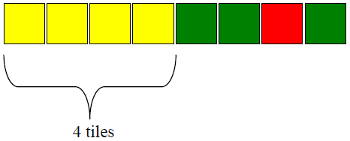
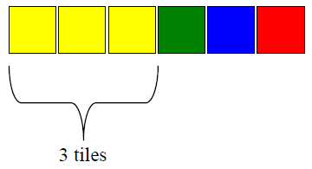

In the first bar three yellow tiles represent ½ and in the second bar four tiles represent ½. Students will gain further understanding that the number of tiles being used (numerator) is always dependent on its relationship to the total number of tiles (denominator)

Before asking students to work on this task, be sure students are able to:
● identify the number of equal pieces needed to cover one whole as the denominator
● show equivalent fractions with an area model
● record on the student sheet equivalent fractions or fraction sets (either by coloring or gluing die cut squares)
● write an equation which shows the clues and verify their answer

Materials

● Colored tiles
● Fraction Clues recording sheet
● Crayons or colored pencils

Task Description

In this task students will use what they have learned about adding and subtracting fractions, using equivalent fractions and multiplying a fraction by a whole number to give another student clues about the fraction strip they created. There is a lot of emphasis on communicating mathematically in this task.

To introduce this activity display these two fraction bars made from Color Tiles.

Ask students to find out what portion of the whole a tile in the first bar represents and what portion of the whole a tile in the second bar represents. Students should be able to determine that each tile in the first bar represents ¼ of the whole and each tile in the second bar represents ¹⁄₆ of the whole.
Ask students to explain what fractional part each color represents in each fraction bar.
Give the following set of fraction clues that describe one of the fraction bars. Stop after each clue and ask children which fraction bar is the solution and how they know.
● The fraction bar is one-half green
● The fraction bar is one-third red
● The fraction is one-sixth blue

Many children will not need all three clues to determine the solution however they should be comfortable arguing and verifying their answers and they may need all three clues to conclude that the solution is the second bar.
Part 2 is a much more challenging version where students create fraction bars with any number of tiles, requiring students to use different denominators, such as 6, 8, 10, and 12. This allows students to develop other strategies for determining the denominator, for example a student may be forced to find a common denominator or they may figure out on their own that the largest denominator must refer to the total number of tiles.

Task Directions
Students will follow directions below from the Fraction Clues activity sheet. .
● Obtain a set of colored tiles.
● Work with a partner to make a fraction bar and record it on their activity sheet.
● Write at least 3 clues that describe your fraction bar
● Exchange only your clues with another group
● Represent your answer with a number sentences (for example: if you have 10 tiles and ½ are red then write the number sentence ¹⁰⁄₂ = 10 x ½ which is 5 tiles)
● Attempt to build another group’s fraction bar as they attempt to build yours.
● Discuss results with each other.

Formative Assessment
● What clues did you write to describe your fraction bar?
● Have you found all of the possible equivalent fractions? How do you know?
● Were you able to build the fraction bar based on the clues? If not, why?
● Could you change any of your clues?
● What number sentence can describe the tiles in your bar?

Differentiation

Extension
● Once students have completed the task above, this lesson can be extended to have two pairs of students combine their fraction bars to make a larger fraction bar, then continue the activity writing clues for another group to solve.

● Students could also be encourage to work with larger fraction bars as well as write more clues for determining those fraction bars. Most color tiles only have red, blue, green and yellow tiles, so the activity will never have more than four fractions to represent.
● Often the clue with the largest denominator tells you how many tiles can be used. However, students could be challenged to use only 2 clues and therefore force them into situations where they need to find common denominators. For example my fractions are ¼ red and ⅓ green. They will then need to build several bars that have 12 or 24 tiles.
Intervention
● If necessary students could begin this activity with a smaller set, such as using only four tiles.
● If students are struggling, they could attempt with activity with only three colors instead of using all four colored tiles.

Name:___________________________________________
Fraction Clues
(Part 1)

Make a Color Tile fraction bar and then write a set of clues so that someone else could build it.

• Work with a partner. Choose 6 Color Tiles and arrange them in any way to form a fraction bar.

• Decide what fractional part of the whole bar is represented by each color you used. For example:
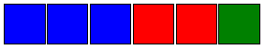

Blue: ³⁄₆ or ½
Red: ²⁄₆ or ⅓
Green: ¹⁄₆

• Record your fraction bar on grid paper. Beneath the grid paper, write several clues that describe the fractional parts of your bar. For example: My bar is ___________ blue.

• Exchange lists with another pair. Be careful not to peek at the back of the list! Follow the clues to try to build the other pair’s fraction bar.

• Represent your answer with a number sentences (for example: if you have 10 tiles and ½ are red, then write the following: Half of 10 = ¹⁰⁄₂ = 10 ÷ ½ = 5 tiles)

• When you have finished making the fraction bar, turn the list of clues over and compare what you built to the recording.

• Discuss your results with the other pair.

Clue 1: ________________________________________________________________________
_________________________________________________________________________

_________________________________________________________________________

_________________________________________________________________________

Clue 2: ________________________________________________________________________
_________________________________________________________________________

_________________________________________________________________________

_________________________________________________________________________

Clue 3: ________________________________________________________________________
_________________________________________________________________________

_________________________________________________________________________

_________________________________________________________________________

Clue 4: ________________________________________________________________________
_________________________________________________________________________

_________________________________________________________________________

_________________________________________________________________________

Work with a partner. Choose 8 color tiles and arrange them in any way to form a fraction bar.

• Decide what fractional part of the whole bar is represented by each color you used. For example:

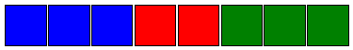
Blue: ⅜
Red: ²⁄₈ or ¼
Green: ⅜

• Record your fraction bar on grid paper. Beneath the grid paper, write several clues that describe the fractional parts of your bar. For example: My bar is ___________ blue.

• Exchange lists with another pair. Be careful not to peek at the back of the list! Follow the clues to try to build the other pair’s fraction bar.

• Represent your answer with a number sentences (for example: if you have 10 tiles and ½ are red then write the number sentence ¹⁰⁄₂ = 10 ÷ 2 = 5 tiles)

• When you have finished making the fraction bar, turn the list of clues over and compare what you built to the recording.

• Discuss your results with the other pair.
Clue 1: ________________________________________________________________________
_________________________________________________________________________

_________________________________________________________________________

_________________________________________________________________________

Clue 2: ________________________________________________________________________
_________________________________________________________________________

_________________________________________________________________________

_________________________________________________________________________

Clue 3: ________________________________________________________________________
_________________________________________________________________________

_________________________________________________________________________

_________________________________________________________________________

Clue 4: ________________________________________________________________________
_________________________________________________________________________

_________________________________________________________________________

_________________________________________________________________________

Work with a partner. Choose 12 Color Tiles and arrange them in any way to form a fraction bar.

• Decide what fractional part of the whole bar is represented by each color you used. For example:

Blue: ⁴⁄₁₂ or ⅓
Red: ²⁄₁₂ or ¹⁄₆
Green: ⁶⁄₁₂ or ½

• Record your fraction bar on grid paper. Beneath the grid paper, write several clues that describe the fractional parts of your bar. For example: My bar is ___________ blue.

• Exchange lists with another pair. Be careful not to peek at the back of the list! Follow the clues to try to build the other pair’s fraction bar.

• Represent your answer with a number sentences (for example: if you have 10 tiles and ½ are red then write the number sentence ¹⁰⁄₂ = 10 ÷2 = 5 tiles)

• When you have finished making the fraction bar, turn the list of clues over and compare what you built to the recording.

• Discuss your results with the other pair.
Clue 1: ________________________________________________________________________
_________________________________________________________________________

_________________________________________________________________________

_________________________________________________________________________

Clue 2: ________________________________________________________________________
_________________________________________________________________________

_________________________________________________________________________

_________________________________________________________________________

Clue 3: ________________________________________________________________________
_________________________________________________________________________

_________________________________________________________________________

_________________________________________________________________________

Clue 4: ________________________________________________________________________
_________________________________________________________________________

_________________________________________________________________________

_________________________________________________________________________

4.NF.4 Area Models
BACKGROUND KNOWLEDGE
On misconception that students may have is that the operation of multiplication produces a larger product and the operation of division produces a smaller quotient. Multiplying whole numbers does produce larger numbers and dividing whole numbers does produce smaller numbers. However, when students begin using these operations with fractions the exact opposite occurs. This task will illustrate that idea.

TASK DESCRIPTION

In this task, students will use area models to demonstrate their conceptual understanding of multiplying a whole number by a fraction. Teachers should support good student dialogue and take advantage of comments and questions to help guide students into correct mathematical thinking.

Comments
The area model of representing fraction is an important way for students to understand both multiplication and division of fractions. This task would allow students some freedom to create their own models and create a miniature book to represent the difference between multiplying a whole number by a fraction and dividing a whole number by another whole number.

Task Directions
Have students follow the directions on the area model recording sheet. Use the square below to draw an area model to represent the following multiplication problems. Use your area model to help you compute the answer to each problem.

FORMATIVE ASSESSMENT QUESTIONS
• What did you notice when you multiplied a whole number by a fraction? Did this surprise you? Why or why not?
• How is multiplying a whole number by a fraction different than multiplying a whole number by another whole number?
How is dividing a whole number by another whole number similar to multiplying a whole number by a fraction?

DIFFERENTIATION
Extension
• Students can extend this activity by creating other models, such as a set model for multiplying a whole number by a fraction.

Intervention
• Students could begin by multiplying whole numbers with fractions that have a numerator of 1, such as ¼, ½, ⅓, before moving on to fractions with larger numerators.

Name:________________________________________

Area Models: Multiplication
Use the squares below to draw an area model to represent the following multiplication problems. Use your area model to help you compute the answer to each problem.

6 • ⅔
Explanation:

Name:________________________________________

Area Models: Multiplication
Use the squares below to draw an area model to represent the following multiplication problems. Use your area model to help you compute the answer to each problem.

8 • ¾
Explanation:

Name:________________________________________

Area Models: Multiplication
Use the squares below to draw an area model to represent the following multiplication problems. Use your area model to help you compute the answer to each problem.

6 • 2/5
Explanation:

Name:________________________________________

Area Models: Multiplication
Use the squares below to draw an area model to represent the following multiplication problems. Use your area model to help you compute the answer to each problem.

8 • ½
Explanation:

4.NF.5 & 6 Decimal Designs
Background Knowledge
While students will have previous experiences expressing fractions with denominators of 10 or 100 as fractions, this will be their first experiences with using decimal notation and investigation into decimal fractions. Students’ understanding of decimal numbers develops in grades 4-5 as follows.
4th Grade – Focus on the relationship between decimal fractions and decimal numbers and investigate the relationship between decimal fractions and decimal numbers, limit to tenths and hundredths, order decimals to hundredths, add decimal fractions with denominators of 10 and 100 (respectively)

ESSENTIAL QUESTIONS
● What is a decimal fraction and how can it be represented?
● “Decimal Designs: Part 1” student recording sheet
● “Decimal Designs: Part 1, Table, Page 1” student recording sheet
● “Decimal Designs: Part 1, Table, Page 2” student recording sheet
● “Decimal Designs: Part 2” student recording sheet
● “Decimal Designs: Part 2, Table” student recording sheet
● Crayons or colored pencils
Task Description
In this task, students will work with occurrences out of 10 and 100, translating them into decimal fractions and then decimals. Students will also explore and investigate the relationship between tenths and hundredths in a visual model and in decimal notation. Students will also begin to rename tenths using hundredths.

This lesson could be introduced by sharing shaded 10-frames and 100 grids to represent a decimal fraction or decimal. For example, share with students some of the designs below.

Discuss strategies students could use to count the number of shaded squares. Did they use multiplication? (e.g. Did they count the number of shaded squares in one part and multiply that number by the number of identical parts in the design? Did they count the number of unshaded squares and subtract from 100?) Once students have determined the decimal fraction and fraction for their favorite design ask students to share their thinking.
Finding the number of shaded squares is one way to give students an opportunity to think about pairs that make 100. As students make their decimal designs on the 10 x 10 grid, ask them if they have more shaded or unshaded. If they have more shaded, ask them to count the number of squares that are UNSHADED and subtract that number from 100 (i.e. think about what number added to the number of unshaded squares would equal 100). This is a great opportunity to review numbers that add up to 100 and for students to explain how they know how many squares are shaded.
During the introduction or mini-lesson, students may need specific instruction on writing and reading decimal fractions and decimals. For example, the 10ths square below shows 5 out of 10 shaded boxes. As a fraction, that would be written as 5/10 , and read, “five tenths.” As a decimal, it would be written as 0.5, and read, “five tenths.” The 100 grid below shows 28 shaded squares out of 100. As a fraction, that would be 28/100 , and read, “twenty-eight hundredths.” As a decimal, it would be written as 0.28 and read, twenty-eight hundredths.”

28/100 or 0.28

It is important for students to recognize that it doesn’t matter where the fractional parts are placed. They can be scattered (above left) or they can be connected (above right).

FORMATIVE ASSESSMENT QUESTIONS

Part 1:
● How many squares are shaded out of 10 (or 100)?
● How many squares total are in the figure?
● What decimal fraction represents the shaded part? How do you know?
● What decimal represents the shaded part? How do you know?
● How would you read the decimal fraction (or decimal) you have written?
● Which students are able to accurately write decimal fractions to describe a shaded region of a design?
● Which students are able to accurately write decimals to describe a shaded region of a design?
● Which students are able to accurately read numbers written in decimal fraction or decimal form?

Part 2:
● How many squares are shaded out of 10 (or 100)?
● How many squares total are in the figure?
● What decimal fraction represents the shaded part? How do you know?
● What decimal represents the shaded part? How do you know?
● How would you read the decimal fraction (or decimal) you have written?
● How are the models of tenths related to the models of hundredths?
● What do the models of the tenths and hundredths have in common? What is different?
● How can a decimal written in tenths be written as a decimal expressed in hundredths?
● Which students are able to accurately write decimal fractions to describe a shaded region
of a design?

● Which students are able to accurately write decimals to describe a shaded region of a
design?

● Which students are able to accurately read numbers written in decimal fraction or decimal
form?
● Which students were able to connect the representations of tenths to the equivalent representation of hundredths?

DIFFERENTIATION
Extension
● Students can be encouraged to conduct a survey of 10 people or 100 people and report the results as a decimal fraction.

Intervention
● Some students may need to continue to represent the decimal fractions and decimals using base 10 blocks. See “Ten is the Winner” and “Rolling Around with Decimals” in this unit for more information about using base 10 blocks to represent decimal fractions and decimals.
Name:________________________________

Decimal Designs: Part 1

Create tenths and hundredths designs and label them accurately.
_____ Shaded boxes out of 10 _______shaded boxes out of 100
Decimal Fraction ________ Decimal_______ Decimal fraction ________

_____ Shaded boxes out of 10 _______shaded boxes out of 100
Decimal Fraction ________ Decimal_______ Decimal fraction ________
Decimal Designs: Part 1 (Table)

1. Look at the example in the table below. Read the following questions and discuss how you would answer them with your partner.
● What do you notice about how “1 out of 10” is written in decimal fraction form?
● What do you notice about how “1 out of 10” is written in decimal form?
● How are they alike? How are they different?
2. Complete the table below. Fill in the last three rows of the table from the “Decimals Designs: Part 1” student recording sheet.
Table, Page 2
1. Look at the example in the table below. Read the following questions and discuss how you would answer them with your partner.

Decimal Designs: Part 1 (Table)
Page 2

1. Look at the example in the table below. Read the following questions and discuss how you would answer them with your partner.
• What do you notice about how “29 out of 100” is written in decimal fraction form?
• What do you notice about how “29 out of 100” is written in decimal form?
• How are they alike? How are they different?
2. Complete the table below. Fill in the last three rows of the table from the “Decimals Designs” student recording sheet.

Name___________________________________ Date_______________________
Decimal Designs: Part 2

Create tenths and hundredths designs that represent the same amount and label them accurately.

Name___________________________________ Date_______________________
Decimal Designs: Part 2 (Table)

Create tenths and hundredths designs that represent the same amount and label them accurately.

1. Look at the example in the table below. Read the following questions and discuss how you would answer them with your partner.
● What do you notice about how “2 out of 10” is written in decimal form using tenths?
● What do you notice about how “20 out of 100” is written in decimal form using hundredths?
2. How are they alike? How are they different?
3. Complete the table below. Fill in the last four rows of the table from the “Decimals Designs: Part 2” student recording sheet.

Input | Output
 | Decimal Fraction  (using tenths) | Decimal  (using tenths)
2 out of 10 | 20/10 | 0.2
20 out of 100 | 20/100 | 0.20
8 out of 10
80 out of 100
___out of 10
___out of 100
___out of 10
___out of 100
4.NF.5 & 6 Flag Fractions

BACKGROUND KNOWLEDGE
This task is expected to follow “Decimal Designs,” therefore students should be familiar with describing a shaded region of a whole as a decimal fraction and as a decimal number.

ESSENTIAL QUESTIONS
● What is a decimal fraction and how can it be represented?
● When is it appropriate to use decimal fractions?
● How are decimal numbers and decimal fractions related?

MATERIALS
● “Flag Fractions, Flags From Around the World” student recording sheet
● “Flag Fractions, Create-a-Flag” student recording sheet
● crayons, colored pencils, or markers
● examples of flags (optional)
Task Description

In this task, students will work to determine the decimal fraction and decimal number represented by each color of a flag. Then students will create their own flag and identify the decimal fraction and decimal number represented by each color of a flag.

This task can be introduced by asking students to write the decimal fraction and decimal number that represents the shaded area of one or more of the decimal patterns students created during the “Decimal Patterns” task.
Allow students to complete the first student sheet, “Flag Fractions, Flags From Around the World” and discuss the results before asking students to create their own flag designs. Students may need assistance estimating the number of blocks to count for each color.
Students should be encouraged to share their work by presenting or posting the flags they created.

FORMATIVE ASSESSMENT QUESTIONS
● How many blocks make up the flag? (100) How many blocks are shaded this color?

● How would you write that as a decimal fraction? How do you know?

● How would you write that as a decimal number? How do you know?

● How do you read this decimal fraction? Decimal number? How do you know?
● How are these numbers (decimal fraction, decimal number) alike? Different?
● How could you estimate the number of blocks that are filled with this color?
● Which students are able to recognize and represent colored regions of the flag using decimal fractions and decimal numbers?

DIFFERENTIATION
Extension
● Explain what your flag color/design represents for your country.

● Ask students to find the value to represent two regions, i.e. how would you represent the combined blue and green regions of the flag?

● Asks students to compare two flags and their graphs. What similarities/differences can be found?

Intervention
● When working on the “Flag Fractions, Flags From Around the World” student recording sheet, allow students to work on the same flag design with a partner or in a small group.

Flag Fractions
Flags from Around the World

Choose one of the flags below. Sketch the flag on the 10 x 10 grid below. When finished, determine the number of sections for each color.
Record your answer as a fraction and a decimal. If one color does not completely fill a box, choose the color that fills the most of the box. (You do not need to sketch a crest, i.e. Paraguay, Portugal, Rwanda, San Marino etc.)

Name:_______________________________

Flag Fractions (Create-a-Flag )

You have the unique opportunity to create your own flag.
1. Decide a name for the country your flag will represent.
2. On the grid paper below, create a flag for the country using as many colors as desired.
3. Complete the chart below.

If one color does not completely fill a box, choose the color that fills the most of the box.

Name of your country ___________________________

Flag for your country:

Fill in the information below for each color used in your flag. If you use more than 4 colors, continue on the back of this paper.
The color represents what part of the flag? | Written as a Decimal fraction | Written as a Decimal Number
4.MD.2 Too Heavy? Too Light?

BACKGROUND KNOWLEDGE
Students need to know which units are within the same system of measurement and how they are related. They will also need to have multi-digit addition and subtraction skills.

MATERIALS
“Too Heavy? Too Light?” student recording sheet

TASK DESCRIPTION

In this task, students will add weights of different units but within the same system. Conversion of units will need to be used.

In this task, students are asked to combine several weights to find the total weight. Since all weights are given using two different units (kg and g, or lb and oz), students must think about how the units are related to each other. For example, students will need to use the following relationships: 1 kg = 1,000 g and 1 lb = 16 oz.

Students may use different strategies to answer the questions on the “Too Heavy? Too Light?” student recording sheet. Some may choose to convert everything to the smaller unit (g or oz) before adding the given weights. Others will try to add the two units separately and then convert, if necessary. It is important to provide the time required for students to share and discuss their different strategies.

FORMATIVE ASSESSMENT QUESTIONS
● What steps did you take to solve the problem?
● Did you convert to smaller units first? Why or why not?
● How could you solve the problem in a different way?
● Why is it important to understand measurement in real life?

DIFFERENTIATION
Extension
● Have students solve the problem in at least two different ways and write about the different strategies, describing the differences. Then have students tell why one is better than the other.
● Ask students to create their own problems using a common situation they may encounter.

Intervention
● Provide the following steps to help solve these problems. Step 1, have students use a drawing with labels to set up the problem. Step 2, have students convert. Step 3, have students solve.
● Before giving students who struggle this task, provide similar problems that been amended. An example is shown below. By eliminating information that is not important for the problem, students are able to focus on the mathematics.
Too Heavy? Too Light?

Answer each of the following problems. Share and discuss how you solved the problems.

Problem 1
Mark has 3 cousins in Michigan whose birthdays are all in February. He wants to send birthday presents to all three of them. Because the
delivery company cannot send a box heavier than 10 kg, he had to weigh the three presents he bought. Their weights were 4 kg 700 g, 2 kg 800 g, and 3 kg 200 g. Can he put all three presents in one box? Why or why not?

Problem 2
Kelly is participating in a bass fishing tournament. In order to advance to the final round, the total weight of the fish she catches must be more than 5 pounds. Kim caught 4 fish that weighed as follow: 1 lb 6 oz, 13 oz, 1 lb 7 oz, and 1 lb 4 oz. Can Kim go on to the final round?

Problem 3
Sam’s Bakery received 15 kg 700 g of sugar. The production manager noticed that they needed 23 kg 100 g of sugar to make the order of cookies she just received. How much more sugar does she need to complete this order of cookies?
4.MD.2 Capacity Line-Up

BACKGROUND
Students should have experience with basic capacity and conservation. Students will also need to be familiar with using liquid measuring tools (e.g. graduated cylinders). Milliliter can be abbreviated as mL or ml. In this unit, mL is used to highlight the liter, but students should be aware that both are acceptable and should be able to recognize the use of ml.
Students believe that larger units will give larger measures. Students should be given multiple opportunities to measure the same object with different measuring units. For example, have the students measure the length of a room with one-inch tiles, with one-foot rulers, and with yard sticks. Students should notice that it takes fewer yard sticks to measure the room than the number of rulers of tiles needed.

For each student
● “Capacity Line-up, Measuring with Graduated Cylinders” student recording sheet

For each group
● 6 containers of different size and shape, labeled A-F (i.e. small jars, cans, plastic containers, and bottles); one should hold at least one liter
● Large bottle of water
● Pan or tray for spillage
● Set of graduated cylinders – be sure graduated cylinders are large enough to measure the capacity of the containers used for this task (be sure the graduated cylinders measure in milliliters (mL)
● 2 sheets construction paper
● Filler, such as sand, small beans, rice, water, etc.
● Tennis ball
● Apple

TASK DESCRIPTION
In this task, students will explore estimation and measurement of capacity and volume with real-world tools. Students will participate in exploratory activities to compare the capacity of different containers.

FORMATIVE ASSESSMENT QUESTIONS
● Does size and shape always affect capacity? Why or why not?
● How can you compare the volume of 2 similar items?
● How did you decide which cylinder to use?
● What must you do to get the most accurate measure?

DIFFERENTIATION
Extension
● Have groups fill the largest container with water and then pour it into the second largest and then the third largest, etc. to see if their progression was correct.

Intervention
● Ask students to complete each row of their table before moving on to another container. This will allow them to develop some experience with capacity before making their next estimate.

Name:______________________________

Capacity Line-Up
Measuring with Graduated Cylinders

Record your estimate for the capacity of each container in the “Estimate” column below. Next, find the best cylinder to use to measure the capacity and record its capacity in the “Cylinder Used” column. Finally, record the capacity of each container in the “Actual Measure” Column.

Container | Estimate | Cylinder Used | Actual Measure
A | __________mL | __________mL | __________mL
B | __________mL | __________mL | __________mL
C | __________mL | __________mL | __________mL
D | __________mL | __________mL | __________mL
E | __________mL | __________mL | __________mL
F | __________mL | __________mL | __________mL
ASSESSMENT TASKS

4. NF.4
c. Solve word problems involving multiplication of a fraction by a whole number, e.g., by using visual fraction models and equations to represent the problem. For example, if each person at a party will eat 3/8 of a pound of roast beef, and there will be 5 people at the party, how many pounds of roast beef will be needed? Between what two whole numbers does your answer lie?
Apply and extend previous understandings of multiplication to multiply a fraction by a whole number.
a. Understand a fraction a/b as a multiple of 1/b. For example, use a visual fraction model to represent 5/4 as the product 5 × (1/4), recording the conclusion by the equation 5/4 = 5 × (1/4).
b. Understand a multiple of a/b as a multiple of 1/b, and use this understanding to multiply a fraction by a whole number. For example, use a visual fraction model to express 3 × (2/5) as 6 × (1/5), recognizing this product as 6/5. (In general, n × (a/b) = (n × a)/b.)
- For a certain brand of orange soda, each can contains cup of sugar.

- How many cups of sugar are there in six cans of this orange soda?

- Draw a picture representing the answer to 2.

- Multiply. Simplify your answer and write it as a proper fraction or as a whole or mixed number.
3 | × |  | =
  1
  8

- Write an addition equation and multiplication equation for the following diagram:

- Problem: 7 x =?

- Charlie operates a hot dog stand. On Wednesday he used of a bag of hot dog buns. On Thursday he used 2 times as many hot dog buns as on Wednesday. How many bags of hot dog buns did Marshal use on Thursday?

- If each person at a party eats of a pound of roast beef, and there are 5 people at the party, how many pounds of roast beef are needed?

- Mike has 4 pounds of ground beef. He makes pound hamburger patties out of the beef. How many patties did he make?

- James had one week to read a book for school. He divided the pages into 7 equal parts. He read one part each day. At the end of the fifth day, what fractional part of the reading was done? How do you know? (Use words, pictures and/or numbers to support your thinking.

4. NF.5
Express a fraction with denominator 10 as an equivalent fraction with denominator 100, and use this technique to add two fractions with respective denominators 10 and 100. For example, express as , and add + = . (Note: Students who can generate equivalent fractions can develop strategies for adding fractions with unlike denominators in general. But, addition and subtraction with unlike denominators is not a requirement at this grade level.

- + =

- A dime is of a dollar and a penny is of a dollar. What fraction of a dollar is 6 dimes and 3 pennies? Write your answer in both fraction and decimal form.

- Write each fraction in expanded fractional form, expanded decimal form, and as a decimal. 43

- Complete the table.
Fraction | Expanded Fraction Form | Expanded Decimal Form | Decimal
43 | 40 + 3 + + | 40+3+0.6+0.05 | 43.65
21
40
7
18

- Finish the equations to make true statements. Write one number in each space.
- 1 tenth + 4 hundredths = ______________ hundredths
- 4 hundredth + 1 tenths = ______________ hundredths
- 5 tenths + 2 hundredths = ______________ hundredths
- 5 hundredths + 2 tenths = ______________ hundredths
- 14 hundredths = __________ hundredths + 4 hundredths
- 14 hundredths = __________ tenths + 4 hundredths
- 14 hundredths = 1 tenths + 3 hundredths + __________ hundredths
- 80 hundredths = __________ tenths

Find the sums.

4. NF.6
Use decimal notation for fractions with denominators 10 or 100. For example, rewrite 0.62 as 62/100; describe a length as 0.62 meters; locate 0.62 on a number line diagram.

- Place these decimals on the line above the fraction they represent: .75, .25, .50
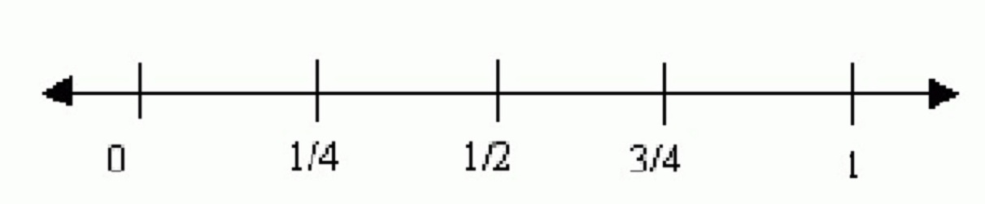
- Shade in the grid to show .45 or forty-five hundredths.
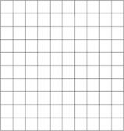

- A decimal number is shown on the grid.

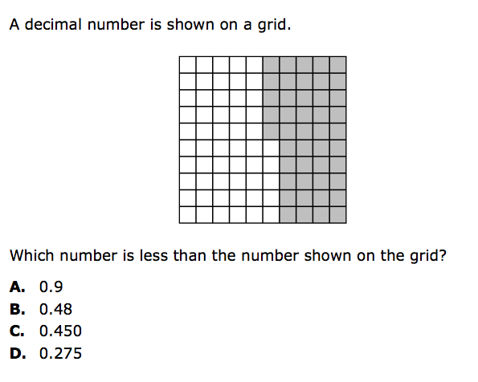
Which number is less that the number shown on the grid?
A. 0.9
B. 0.48
C. 0.450
D. 0.275

- Which fraction is equivalent to 0.23?
- B.
C.
D.

4. MD.2
Use the four operations to solve word problems involving distances, intervals of time, liquid volumes, masses of objects, and money, including problems involving simple fractions or decimals, and problems that require expressing measurements given in a larger unit in terms of a smaller unit. Represent measurement quantities using diagrams such as number line diagrams that feature a measurement scale.
Susan has 2 feet of ribbon. She wants to give her ribbon to her 3 best friends so each friend gets the same amount. How much ribbon will each friend get?

- Ryan ran for an hour and 15 minutes on Monday, 25 minutes on Tuesday, and one hour and 10 minutes on Wednesday. What was the total number of minutes Ryan ran?

- A pound of apples costs $1.20. Annalee bought two and a half pounds of apples. If she gave the clerk a $5.00 bill, how much change will she get back?

- Margie bought 3 apples that cost 50 cents each. She paid with a five-dollar bill. How much change did Margie receive?

Pasta Party
4.NF.4 - Task 1
Materials | Paper and pencil
Task | Part 1:  Katie makes 1/4 pound of pasta for each person at her dinner party. If seven people attend the party, how many pounds of pasta will be needed for her guests?  Write an addition equation to show this situation.  Show your answer with a number line or an area model.  Use numbers or words to explain how your model shows addition.  Part 2:  Write a multiplication equation to show this situation.  Show your answer with a number line or an area model.  Use numbers or words to explain how your model shows multiplication.  Part 3  How are your addition and multiplication equations alike? Different?  Would you use one over the other? Why or why not?  Extension:  Students can write their own word problem using ¼ x 7.

Rubric
Level I | Level II | Level III
Limited Performance  Part 1: Student is unable to write an addition equation or draw a model.  Part 2: Student is unable to write a multiplication equation or draw a model. | Not Yet Proficient  Part 1: Student writes a correct addition equation that totals 7/4 (i.e., ¼ + ¼ + ¼ + ¼ + ¼ + ¼ + ¼ = 7/4), but is unable to show the sum on a number line as seven ‘jumps’ of ¼, or as an area model, and does not clearly explain how the model matches their addition equation.  Part 2: Student writes a correct multiplication equation (¼ x 7= 7/4), but is unable to show the total 7/4 on a number line or area model, and does not clearly explain how the model matches their multiplication equation.  Part 3: Students have some idea how they are alike and different. | Proficient in Performance  Part 1: Student writes a correct addition equation that totals 7/4 (i.e., ¼ + ¼ + ¼ + ¼ + ¼ + ¼ + ¼ = 7/4).They show the sum on a number line as seven ‘jumps’ of ¼, or as an area model, and clearly explain how the model matches their addition equation.  Part 2: Student writes a correct multiplication equation (¼ x 7= 7/4). They show the total 7/4 on a number line or area model, and clearly explain how the model matches their multiplication equation.  Part 3: Students understand how they are alike and different and clearly states.

Drawing a Model
4.NF.4 Task 2
Materials | Paper and pencil
Task | Part 1:  Kelly was making curtains for her living room. She bought four pieces of fabric that were each 2/3 yard long. How many yards of fabric did Kelly buy in all?  Draw a picture and write an equation to show the total amount of fabric if each piece is 2/3 yard long.  Part 2:  With the fabric that she bought in part 1, Kelly cut each piece of fabric into a 1/3 yard long piece. Draw a picture and write an equation to show the total amount of fabric if each piece is 1/3 yard long.  Part 3:  Is the amount of fabric in Part 1 and Part 2 the same? Use pictures to prove it. Write a sentence to explain how you know that you are correct.

Rubric
Level I | Level II | Level III
Limited Performance  Part 1  Student is unable to create a correct equation and/or picture.  Part 2  Student is unable to create a correct equation and/or picture.  Part 3  The student cannot draw a model to show this relationship or explain it in words or numbers. | Not Yet Proficient  Part 1  addition equation  2/3 + 2/3 + 2/3 + 2/3 = 8/3  multiplication equation  4 x 2/3 = 8/3  Picture should show four groups of 2/3.  Part 2  Addition equation  1/3 + 1/3 + 1/3 + 1/3 + 1/3 +1/3 + 1/3 + 1/3= 8/3  Multiplication equation  8 x 1/3 = 8/3  Picture should show eight groups of 1/3  Part 3  It is unclear from the student’s picture that they understand the relationship 8/3 = 4 x 2/3. | Proficient in Performance  Part 1  addition equation  2/3 + 2/3 + 2/3 + 2/3 = 8/3  multiplication equation  4 x 2/3 = 8/3  Picture should show four groups of 2/3.  Part 2  Addition equation  1/3 + 1/3 + 1/3 + 1/3 + 1/3 +1/3 + 1/3 + 1/3= 8/3  Multiplication equation  8 x 1/3 = 8/3  Picture should show eight groups of 1/3  Part 3  Picture and explanation should show that eight individual copies of one third can be grouped as four groups of two-thirds. Equations: 8 x 1/3 = 4 x 2/3

Karen’s Garden
4.NF.5 Task 1
Materials | Decimal grids (hundredths grids), base ten blocks (optional), paper and pencil
Task | In this task, students will be using decimal grids (hundredths) to shade in tenths and hundredths as decimals and fractions, and find totals and differences.  Introduce the manipulatives and task with the following practice problem.  Karen is planting vegetables in her 10’ x 10’ garden. She wants 3/10 of the garden to be tomatoes. If Karen has already planted peas in 0.25 of the garden, how much space will she have left for other vegetables?  Some students may be comfortable using hundredths grids while others may need the additional support of using base ten blocks (flat = 1 whole, ten stick = 1/10, unit cube = 1/100).  Students may work on the Karen’s Garden sheet independently or in pairs if they need support. As they work, they should shade in hundredths grids or use base ten blocks to solve the addition or subtraction.

Rubric
Level I | Level II | Level III
Limited Performance  - Solutions will include many errors in conversions and equivalencies, as well as addition and subtraction errors. Students may struggle to choose appropriate numbers from the problems for computation. | Not Yet Proficient  - Students should be able to convert decimals (tenths and hundredths) to fractions with 10 or 100 as a denominator. Their solutions should show that they can work flexibly with fractions and decimals.  - At this level, their solutions will include errors in several conversions and equivalencies. | Proficient in Performance  - At this level, their solutions will include few or no errors in conversions and equivalencies.  Possible solutions:  - 76/100 + 24/100 = 100/100  - 0.6 + 0.23 = 0.83  6/10 + 23/100 = 83/100  60/100 + 23/100 = 83/100  - 0.5 – 0.14 = 0.36  0.14 + 0.36 = 0.50  14/100 + 36/100 = 5/10 or 50/100  - 2/10 + 0.2 + 20/100 = 0.6 or 6/10 or 60/100  - Students should figure out that 0.6 + 0.36 = 0.96 of the original grid, so 0.04 would be leftover for radishes. If radishes are now taking up 22/100 of the garden, 0.22 – 0.04 = 0.18. The deer ate peas in 0.18 of the garden.

Filling the Jar
4.NF.5 Task 2
Materials | Decimal grids (hundredths grids), base ten blocks (optional), paper and pencil
Task | In this task, students will be using decimal grids (hundredths) to shade in tenths and hundredths as decimals and fractions, and find totals and differences.  Part 1:  A jar can hold 100 marbles. For each of the situations below, find the amount for the various colors of marbles.  Jar A: The jar contains $\frac{3}{\text{10}}$ blue, $\frac{2}{\text{10}}$ white, and $\frac{\text{19}}{\text{100}}$ red marbles. The rest are yellow. What fraction represents the number of yellow marbles? _____  Jar B: $\frac{7}{\text{10}}$ green, $\frac{1}{\text{10}}$ purple, and $\frac{4}{\text{100}}$ brown. The rest are white. What fraction represents the number of white marbles? ______  Jar C: $\frac{3}{\text{10}}$ gray and $\frac{\text{51}}{\text{100}}$ black. The rest are pink or yellow. There are more pink than yellow marbles. What fraction represents the number of pink and yellow marbles? ____ pink, ____ yellow.  Jar D: $\frac{2}{\text{10}}$ clear and $\frac{\text{18}}{\text{100}}$ orange. The rest are red and blue. There are 2 more red marbles than blue marbles.  What fraction represents the number of red and blue marbles? ___ red, ____ blue.  Part 2: Pick one of the tasks above. Explain how you worked with the different denominators to find your answer.  Some students may be comfortable using hundredths grids while others may need the additional support of using base ten blocks (flat = 1 whole, ten stick = 1/10, unit cube = 1/100).
Rubric
Level I |  | Level II |  | Level III
Limited Performance  - Solutions will include many errors in conversions and equivalencies, as well as addition and subtraction errors. Students may struggle to choose appropriate numbers from the problems for computation. |  |  | Not Yet Proficient  - Students should be able to convert decimals (tenths and hundredths) to fractions with 10 or 100 as a denominator. Their solutions should show that they can work flexibly with fractions and decimals.  - At this level, their solutions will include errors in several conversions and equivalencies. |  | Proficient in Performance  - Students correctly find the answer to each problem. Jar A: 31/100 yellow. Jar B: 16/100 white. Jar C: Multiple possible answers. Both fractions must add up to 19/100 and the fraction for pink must be greater than yellow. Jar D: Red: 32/100, Blue: 30/100.  - Part 2: The answer discusses that tenths can also be written as hundredths by multiplying the numerator and denominator both by 10.

Where am I now? How much farther?
4.NF.6 Task 1
Materials | Decimal grids (hundredths grids), base ten blocks (optional), paper and pencil
Task | Where am I now? How much farther?  Part 1:  You have walked 0.32 of the way from your house to the school.  - What is that distance as a fraction?  - If you walk another 17/100 of the way to the school how far have you gone now in terms of both a fraction and a decimal?  - If you walk another 3/10 of the way to the school how far have you gone now in terms of both of a fraction and a decimal?  - Draw a number line from 0 to 1 and label each tenth on the number line. Plot the three distances above as both fractions and decimals.  Part 2:  Write an explanation explaining how you worked with equivalent fractions and decimals to solve this task.

Rubric
Level I | Level II | Level III
Limited Performance  - Solutions will include many errors in conversions and equivalencies, as well as addition and subtraction errors. Students may struggle to choose appropriate numbers from the problems for computation. | Not Yet Proficient  - Students should be able to convert decimals (tenths and hundredths) to fractions with 10 or 100 as a denominator. Their solutions should show that they can work flexibly with fractions and decimals.  - At this level, their solutions will include errors in several conversions and equivalencies. | Proficient in Performance  - Students correctly find the answer to each problem. A) 32/100. B) 49/100, C) 79/100, D) all 3 fractions and decimals are correctly plotted on a number line.  - Part 2: The answer discusses that tenths can also be written as hundredths by multiplying the numerator and denominator both by 10, and that decimals are equivalent to fractions that have either a 10 or 100 in the denominator.

Is the tire full yet?
4.NF.6 Task 2
Materials | Decimal grids (hundredths grids), base ten blocks (optional), paper and pencil
Task | Is the tire full?  Part 1:  You are about to go on vacation with your family. Your tire is 78/100 full of air. If you add air so that it 0.93 full, what fraction of the tire did you just fill with air? What fraction (and decimal) of the tire still needs to be filled with air?  Part 2:  Write an explanation explaining how you worked with equivalent fractions and decimals to solve this task.

Rubric
Level I | Level II | Level III
Limited Performance  - Solutions will include many errors in conversions and equivalencies, as well as addition and subtraction errors. Students may struggle to choose appropriate numbers from the problems for computation. | Not Yet Proficient  - Students should be able to convert decimals (tenths and hundredths) to fractions with 10 or 100 as a denominator. Their solutions should show that they can work flexibly with fractions and decimals.  - At this level, their solutions will include errors in several conversions and equivalencies. | Proficient in Performance  - Students correctly find the answer to each problem. A) 15/100 or 0.15. B) 7/100 or 0.07.  - Part 2: The answer discusses that tenths can also be written as hundredths by multiplying the numerator and denominator both by 10, and that decimals are equivalent to fractions that have either a 10 or 100 in the denominator.

Weighing the Books
4.MD.2-Task 1
Materials | Paper and pencil
Weighing the Books
Mrs. Floyd and her classmates want to know how heavy a few of the books in their classroom are.
Part 1:
They want to know the masses of the objects in ounces; however the scale only gives the mass in pounds. Using the table below, find out how many ounces each book is.
Math book | 2 1/2 pounds
Science book | 3 1/3 pounds
Dictionary | 5 1/8 pounds
Part 2:
Two copies of one book and two copies of another book weigh a total of 6 pounds. Each book weighs a whole number of ounces. How many ounces could each book weigh? Explain how you solved this problem.
Rubric
Level I |  | Level II | Level III
Limited Performance  - Students make more than 2 errors. |  | Not Yet Proficient  - Students make 1 or 2 errors OR their explanation is not accurate. | Proficient in Performance  - Part 1: Math: 40 ounces, Science: 53 1/3 ounces, Dictionary: 82 ounces.  - Part 2: The books should have a combined weight of 48 ounces, since 2 copies of both books will be 6 pounds or 96 ounces.  - AND there is a clear and accurate explanation about how they found the distances in inches.

Getting Ready for School
4.MD.2-Task 2
Standard(s) | 4.MD.2 Use the four operations to solve word problems involving distances, intervals of time, liquid volumes, masses of objects, and money, including problems involving simple fractions or decimals, and problems that require expressing measurements given in a larger unit in terms of a smaller unit. Represent measurement quantities using diagrams such as number line diagrams that feature a measurement scale.
Materials | Paper and pencil
Getting Ready for School
The bus comes to Steve’s house at 8:15 a.m. Prior to getting on the bus, he needs to:
Eat breakfast: 15 minutes
Shower: 8 minutes
Get dressed: 7 minutes
Read a book: 12 minutes
Part 1:
What is the latest that Steve can get up and still be on time for the bus?

Part 2:
It takes Steve’s sister, Rachel, twice as long to get dressed and 5 minutes longer to eat breakfast. What is the latest Rachel can get up and still be on time for the bus? Write a sentence to explain how you found your answer.

Rubric
Level I | Level II | Level III
Limited Performance  - Students make more than 2 errors. | Not Yet Proficient  - Students make 1 or 2 errors OR their explanation in Part 3 is not accurate. | Proficient in Performance  - Part 1: Steve needs to be up by 7:33 a.m. Part 2: Rachel needs to be up by 7:21 a.m.  - AND the explanation is clear and accurate.

Extensions and Sources
Online Resources

Common Core Tools
http://commoncoretools.me/
http://www.ccsstoolbox.com/
http://www.achievethecore.org/steal-these-tools
Manipulatives
http://nlvm.usu.edu/en/nav/vlibrary.html
http://www.explorelearning.com/index.cfm?method=cResource.dspBrowseCorrelations&v=s&id=USA-000
http://www.thinkingblocks.com/
Problem Solving Resources
*Illustrative Math Project
http://illustrativemathematics.org/standards/k8
http://illustrativemathematics.org/standards/hs
The site contains sets of tasks that illustrate the expectations of various CCSS in grades K–8 grade and high school. More tasks will be appearing over the coming weeks. Eventually the sets of tasks will include elaborated teaching tasks with detailed information about using them for instructional purposes, rubrics, and student work.
*Inside Mathematics
http://www.insidemathematics.org/index.php/tools-for-teachers
Inside Mathematics showcases multiple ways for educators to begin to transform their teaching practices. On this site, educators can find materials and tasks developed by grade level and content area.

IXL
http://www.ixl.com/
Sample Balance Math Tasks
http://www.nottingham.ac.uk/~ttzedweb/MARS/tasks/
New York City Department of Education
http://schools.nyc.gov/Academics/CommonCoreLibrary/SeeStudentWork/default.htm
NYC educators and national experts developed Common Core-aligned tasks embedded in units of study to support schools in implementation of the CCSSM.
*Georgia Department of Education
https://www.georgiastandards.org/Common-Core/Pages/Math-K-5.aspx
Georgia State Educator have created common core aligned units of study to support schools as they implement the Common Core State Standards.
Gates Foundations Tasks
http://www.gatesfoundation.org/college-ready-education/Documents/supporting-instruction-cards-math.pdf
Minnesota STEM Teachers’ Center
http://www.scimathmn.org/stemtc/frameworks/721-proportional-relationships
Singapore Math Tests K-12
http://www.misskoh.com
Math Score:
Math practices and assessments online developed by MIT graduates.
http://www.mathscore.com/
Massachusetts Comprehensive Assessment System
www.doe.mass.edu/mcas/search
Performance Assessment Links in Math (PALM)
PALM is currently being developed as an on-line, standards-based, resource bank of mathematics performance assessment tasks indexed via the National Council of Teachers of Mathematics (NCTM).
http://palm.sri.com/
Mathematics Vision Project
http://www.mathematicsvisionproject.org/
*NCTM
http://illuminations.nctm.org/
Assessment Resources
  - *Illustrative Math: http://illustrativemathematics.org/
  - *PARCC: http://www.parcconline.org/samples/item-task-prototypes
  - NJDOE: http://www.state.nj.us/education/modelcurriculum/math/ (username: model; password: curriculum)
  - DANA: http://www.ccsstoolbox.com/parcc/PARCCPrototype_main.html
  - New York: http://www.p12.nysed.gov/assessment/common-core-sample-questions/
  - *Delaware: http://www.doe.k12.de.us/assessment/CCSS-comparison-docs.shtml

PARCC Prototyping Project
Elementary Tasks (ctrl+click) | Middle Level Tasks (ctrl+click) | High School Tasks (ctrl+click)
- Flower gardens (grade 3)  - Fractions on the number line (grade 3)  - Mariana’s fractions (grade 3)  - School mural (grade 3)  - Buses, vans, and cars (grade 4)  - Deer in the park (grade 4)  - Numbers of stadium seats (grade 4)  - Ordering juice drinks (grade 4) | - Cake weighing (grade 6)  - Gasoline consumption (grade 6)  - Inches and centimeters (grade 6)  - Anne’s family trip (grade 7)  - School supplies (grade 7)  - Spicy veggies (grade 7)  - TV sales (grade 7) | - Cellular growth  - Golf balls in water  - Isabella’s credit card  - Rabbit populations  - Transforming graphs of quadratic functions
Professional Development Resources
Edmodo
http://www.edmodo.com
Course: iibn34
Clark County School District Wiki Teacher
http://www.wiki-teacher.com/wikiDevelopment/unwrappedSearch.php#contentAreaId=6&courseId=474
Learner Express Modules for Teaching and Learning
http://www.learner.org/series/modules/express/videos/video_clips.html?type=1&subject=math
Additional Videos
http://www.achieve.org/achieving-common-core; http://www.youtube.com/user/TheHuntInstitute/videos
Mathematical Practices
Inside Mathematics
http://www.insidemathematics.org/index.php/commmon-core-math-intro
Also see the Tools for Educators
The Teaching Channel
https://www.teachingchannel.org
*Learnzillion
https://www.learnzillion.com
*Engage NY
http://www.engageny.org/video-library?f[0]=im_field_subject%3A19

*Adaptations of the these resources has been included in various lessons.

