4th Grade: Unit 2
Curriculum Map: October 28 - January 3

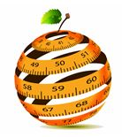

REVIEW OF GRADE 3 FLUENCIES
3.OA.7 | Fluently add and subtract within 20 using mental strategies.  By end of Grade 2, know from memory all sums of two one-digit numbers.
3.NBT.2 | Fluently add and subtract within 100 using strategies based on place value, properties of operations, and/or the relationship between addition and subtraction.

EXPECTED GRADE 4 FLUENCIES
4.NBT.4 | Fluently add and subtract multi-digit whole numbers using the standard algorithm. Add and Subtract within 1,000,000

Grade 4 Operations and Algebraic Thinking

4.OA.1 | Interpret a multiplication equation as a comparison, e.g., interpret 35 = 5 × 7 as a statement that 35 is 5 times as many as 7 and 7 times as many as 5. Represent verbal statements of multiplicative comparisons as multiplication equations.
A multiplicative comparison is a situation in which one quantity is multiplied by a specified number to get another quantity (e.g., “a is n times as much as b”). Students should be able to identify and verbalize which quantity is being multiplied and which number tells how many times.
4.OA.2 | Multiply or divide to solve word problems involving multiplicative comparison, e.g., by using drawings and equations with a symbol for the unknown number to represent the problem, distinguishing multiplicative comparison from additive comparison.
Students need many opportunities to solve contextual problems. Table 2 includes the following multiplication problem:

“A blue hat costs $6. A red hat costs 3 times as much as the blue hat. How much does the red hat cost?”

In solving this problem, the student should identify $6 as the quantity that is being multiplied by 3.
The student should write the problem using a symbol to represent the unknown.
($6 x 3 =_____ )

Table 2 includes the following division problem:

A red hat costs $18 and a blue hat costs $6. How many times as much does the red hat cost as the blue hat?

In solving this problem, the student should identify $18 as the quantity being divided into shares of $6.

The student should write the problem using a symbol to represent the unknown. ($18 ÷ $6 = )
When distinguishing multiplicative comparison from additive comparison, students should note that:

- Additive comparisons focus on the difference between two quantities (e.g., Deb has 3 apples and Karen has 5 apples. How many more apples does Karen have?). A simple way to remember this is, “How many more?”
- multiplicative comparisons focus on comparing two quantities by showing that one quantity is a specified number of times larger or smaller than the other (e.g., Deb ran 3 miles. Karen ran 5 times as many miles as Deb. How many miles did Karen run?). A simple way to remember this is “How many times as much?” or “How many times as many?”
4.OA.3 | Solve multi step word problems posed with whole numbers and having whole number answers using the four operations, including problems in which remainders must be interpreted.
Students need many opportunities solving multistep story problems using all four operations.

An interactive whiteboard, document camera, drawings, words, numbers, and/or objects may be used to help solve story problems.

Example:
Chris bought clothes for school. She bought 3 shirts for $12 each and a skirt for $15. How much money did Chris spend on her new school clothes?
3 x $12 + $15 = a

In division problems, the remainder is the whole number left over when as large a multiple of the divisor as possible has been subtracted.

Example:
Kim is making candy bags. There will be 5 pieces of candy in each bag. She had 53 pieces of candy. She ate 14 pieces of candy. How many candy bags can Kim make now? (7 bags with 4 leftover)

Kim has 28 cookies. She wants to share them equally between herself and 3 friends. How many cookies will each person get? (7 cookies each) 28 ÷ 4 = a

There are 29 students in one class and 28 students in another class going on a field trip. Each car can hold 5 students. How many cars are needed to get all the students to the field trip? (12 cars, one possible explanation is 11 cars holding 5 students and the 12th holding the remaining 2 students) 29 + 28 = 11 x 5 + 2

Estimation skills include identifying when estimation is appropriate, determining the level of accuracy needed, selecting the appropriate method of estimation, and verifying solutions or determining the reasonableness of situations using various estimation strategies. Estimation strategies include, but are not limited to:

- front-end estimation with adjusting (using the highest place value and estimating from the front end, making adjustments to the estimate by taking into account the remaining amounts),
- clustering around an average (when the values are close together an average value is selected and multiplied by the number of values to determine an estimate),
- rounding and adjusting (students round down or round up and then adjust their estimate depending on how much the rounding affected the original values),
- using friendly or compatible numbers such as factors (students seek to fit numbers together - e.g., rounding to factors and grouping numbers together that have round sums like 100 or 1000),
- using benchmark numbers that are easy to compute (students select close whole numbers for fractions or decimals to determine an estimate).

4.OA.4 | Find all factor pairs for a whole number in the range 1-100. Recognize that the whole number is a multiple of each of its factor.
Students should understand the process of finding factor pairs so they can do this for any number 1
-100,

Example:
Factor pairs for 96: 1 and 96, 2 and 48, 3 and 32, 4 and 24, 6 and 16, 8 and 12.

Multiples can be thought of as the result of skip counting by each of the factors. When skip
counting, students should be able to identify the number of factors counted e.g., 5, 10, 15, 20
(there are 4 fives in 20).

Example:
Factors of 24: 1, 2, 3, 4, 6, 8,12, 24
Multiples : 1,2,3,4,5…24
2,4,6,8,10,12,14,16,18,20,22,24
3,6,9,12,15,18,21,24
4,8,12,16,20,24
8,16,24
12,24
24

To determine if a number between1-100 is a multiple of a given one-digit number, some helpful
hints include the following:
- all even numbers are multiples of 2
- all even numbers that can be halved twice (with a whole number result) are multiples of 4
- all numbers ending in 0 or 5 are multiples of 5

Prime vs. Composite:
A prime number is a number greater than 1 that has only 2 factors, 1 and itself. Composite numbers have more than 2 factors.

Students investigate whether numbers are prime or composite by
- building rectangles (arrays) with the given area and finding which numbers have more than two rectangles (e.g. 7 can be made into only 2 rectangles, 1 x 7 and 7 x 1, therefore it is a prime number)
- finding factors of the number.

4.OA.5 | Generate a number or shape pattern that follows a given rule. Identify apparent features of the pattern that were not explicit in the rule itself. For example, given the rule “Add 3” and the starting number 1, generate terms in the resulting sequence and observe that the terms appear to alternate between odd and even numbers. Explain informally why the numbers will continue to alternate in this way.
Patterns involving numbers or symbols either repeat or grow. Students need multiple opportunities creating and extending number and shape patterns. Numerical patterns allow students to reinforce facts and develop fluency with operations.

Patterns and rules are related. A pattern is a sequence that repeats the same process over and over. A rule dictates what that process will look like. Students investigate different patterns to find rules, identify features in the patterns, and justify the reason for those features.

Examples:

Patterns | Rule | Feature
3, 8, 13, 18, 23,  28, … | Start with 3 add 5 | The numbers alternately end with a 3 or  8
5, 10, 15, 20 … | Start with 5,  add 5 | The numbers are multiples of 5 and end with either 0 or 5. The numbers that end with 5 are products of 5 and an odd number.  The numbers that end in 0 are products  of 5 and an even number.

After students have identified rules and features from patterns, they need to generate a numerical
or shape pattern from a given rule.

Example:
Rule: Starting at 1, create a pattern that starts at 1 and multiplies each number by 3. Stop when
you have 6 numbers. Students write 1, 3, 9, 27, 81, 243. Students notice that all the numbers are odd and that the sums of the digits of the 2 digit numbers are each 9. Some students might investigate this beyond 6 numbers. Another feature to investigate is the patterns in the differences of the numbers (3 – 1 = 2, 9 – 3 = 6, 27 – 9 = 18, etc.)

Grade 4 Number and Operation base Ten

4.NBT.3 | Use place value understanding to round multi-digit whole numbers to any place.
When students are asked to round large numbers, they first need to identify which digit is in the
appropriate place.

Example: Round 76,398 to the nearest 1000.
• Step 1: Since I need to round to the nearest 1000, then the answer is either 76,000 or
77,000.
• Step 2: I know that the halfway point between these two numbers is 76,500.
• Step 3: I see that 76,398 is between 76,000 and 76,500.
• Step 4: Therefore, the rounded number would be 76,000.
4.NBT.5 | Multiply a whole number of up to four digits by a one-digit whole number, and multiply two two-digit numbers, using strategies based on place value and the properties of operations. Illustrate and explain the calculation by using equations, rectangular arrays, and/or area models.
Students who develop flexibility in breaking numbers apart have a better understanding of the importance of place value and the distributive property in multi-digit multiplication. Students use base ten blocks, area models, partitioning, compensation strategies, etc. when multiplying whole numbers and use words and diagrams to explain their thinking. They use the terms factor and product when communicating their reasoning. Multiple strategies enable students to develop
fluency with multiplication and transfer that understanding to division. Use of the standard algorithm for multiplication is an expectation in the 5th grade.
Students may use digital tools to express their ideas.

Use of place value and the distributive property are applied in the scaffold examples below.
- To illustrate 154 x 6 students use base 10 blocks or use drawings to show 154 six times. Seeing 154 six times will lead them to understand the distributive property, 154 X 6 = (100 + 50 + 4) x 6 = (100 x 6) + (50 X 6) + (4 X 6) = 600 + 300 + 24 = 924.
- The area model shows partial products. 14 x 16 = 224
Using the area model, students
first verbalize their understanding:
• 10 x 10 is 100
• 4 x 10 is 40
• 10 x 6 is 60, and
• 4 x 6 is 24.

- Students explain this strategy and the one below with base 10 blocks, drawings, or numbers.
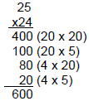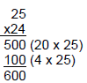

- Matrix model
This model should be introduced after students have facility with the strategies shown
above.

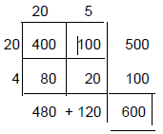

Grade 4 Number and Operation - Fractions

4.NF.7 | Compare two decimals to hundredths by reasoning about their size. Recognize that comparisons are valid only when the two decimals refer to the same whole. Record the results of comparisons with the symbols >, =, or <, and justify the conclusions, e.g., by using a visual model.
Students build area and other models to compare decimals. Through these experiences and their work with fraction models, they build the understanding that comparisons between decimals or fractions are only valid when the whole is the same for both cases. Each of the models below shows 3/10 but the whole on the right is much bigger than the whole on the left. They are both 3/10 but the model on the bottom is a much larger quantity than the model on the top.

When the wholes are the same, the decimals or fractions can be compared.
Example:

- Draw a model to show that 0.3 < 0.5. (Students would sketch two models of approximately the same size to show the area that represents three-tenths is smaller than the area that represents five-tenths.

Unit 2 Model Curriculum Student Learning Objectives

# | Student Learning Objective | CCSS
1 | Write multiplication equations from multiplicative comparisons given in words (example, 35 is 5 times as many as 7 and 7 times as many as 5) and describe a multiplication equation in words. | 4.OA.1
2 | Multiply or divide to solve word problems involving multiplicative comparisons. Write an equation to identify the arithmetic operation written in a word problem (without solving). | 4.OA.2
3 | Compose equations from information supplied in word problems (with all 4 operations) using letters to represent unknowns (without solving). | 4.OA.3
4 | Determine if a number between 1 and 100 is a prime or composite number.  Find all factor pairs for a whole number up to 100 and determine whether it is a multiple of a given 1-digit whole number. | 4.OA.4
5 | Generate number or shape patterns by using rules including words, models, or graphs, and identify apparent features of the pattern that were not explicit in the rule of the original pattern. For example, given the rule “Add 3” and the starting number 1, generate terms in the resulting sequence and observe that the terms appear to alternate between odd and even numbers. | 4.OA.5
6 | Round multi-digit whole numbers up to one million to any place. | 4.NBT.3
7 | Use strategies to multiply multi-digit numbers, and explain the answer using equations, rectangular arrays, and area models (up to 4-digits by 1-digit or 2-digits by 2-digits). | 4.NBT.5
8 | Compare two decimals to hundredths by reasoning about their size. Recognize that comparisons are valid only when the two decimals refer to the same whole. Record the results of comparisons with the symbols >, =, or <, and justify the conclusions, e.g., by using a visual model. | 4.NF.7

Potential Student Misconceptions

Numbers and Operations in Base Ten
Students misinterpret the value of digits in multi-digit numbers.
Students need to understand that when you have ten of one unit, you also have one unit of the next higher value. Frequently refer to a place value chart and connect the digits to conceptual models, i.e., place value blocks and pictorial representations. Have students create multiple ways to represent numbers, such as 132 can be made of 1 hundred, 3 tens and 2 ones, or 1 hundred, 1 ten and 22 ones, or 12 tens and 12 ones. When explaining strategies used, students must identify the unit value; e.g., when adding 492 and 265, they state that they are adding “two hundred” to “four hundred”, i.e., the 2 in 265 is named “two hundred,” rather than “two.”
Students may not distribute for every value in the equation when applying the distributive property with multi-digit factors.
Student may solve 13 x 25 by only multiplying 10 x 20 (the tens place values) and 3 x 5 (the ones place values) missing that 10 x 5 and 20 x 3 (tens place times ones place values) are necessary. Encourage students to use visual models, such as open arrays or base ten blocks, that help students visually keep track of all the partial products.

Operation and Algebraic Thinking
Students misinterpret the value of digits in multi-digit numbers.
Students need to understand that when you have ten of one unit, you also have one unit of the next higher value. Frequently refer to a place value chart and connect the digits to conceptual models, i.e., place value blocks and pictorial representations. Have students create multiple ways to represent numbers, such as 132 can be made of 1 hundred, 3 tens and 2 ones, or 1 hundred, 1 ten and 22 ones, or 12 tens and 12 ones. When explaining strategies used, students must identify the unit value; e.g., when adding 492 and 265, they state that they are adding “two hundred” to “four hundred”, i.e., the 2 in 265 is named “two hundred,” rather than “two.”

Students confuse multiples with factors.
Use the words multiples and factors in context frequently, and have students do the same. When students practice skip counting, label this “Practicing Multiples.” Keep the words “factor” and “multiple” on a vocabulary chart, and refer to it when confusion arises.

Students may not recognize that a number is a multiple of itself.
When listing multiples of numbers, emphasize that the smallest multiple is the number itself.

Students may think that larger numbers have more factors.
Provide students with opportunities to investigate all the arrays for given numbers. Use the arrays to list the factors for those numbers. Discuss reasons why some numbers have more factors than other numbers, e.g., some prime numbers are only divisible by 1 and the number itself.

Students misunderstand the meaning of the equal sign.
The equal sign means “is the same quantity as” but many students believe the equal sign tells you that the “answer is coming up” to the right of the equal sign. Students need to see equations, and write equations, in multiple ways. It is important to model equations in various ways, e.g., 188 = 100 + 80 + 8, or 95 + 15 = 100 + 10.

Numbers and Operations - Fractions
Students may use the denominator as the decimal when converting fractions to decimals.
Students need many opportunities with models, e.g., hundred grids, money. Students will then be able to verify their thinking about ½ ; e.g., a student might say ½ = .2 or .20 instead of .5 or .50, however using a model would resolve this misconception.

Pacing Guide
EDM Section | Common Core Standards/SLO | Additional Instructions/Notes
3-1 What’s my rule? | 4.OA.5  SMP 2 | Mental Math and Reflexes  Math Message  Part 1 & 2  Student Journal p. 53 & 54 (review)  Math Boxes p. 55  Teaching Master p. 73/74
3-2 Multiplication Facts | 4.OA.1, 4.OA.4  SMP 2, SMP 5 | Mental Math and Reflexes  Math Message  Part 1 , 2 & 3 Readiness and Extra Practice  Student Journal p. 56  Math Boxes p. 57 # 1,2,4,5  Math Masters p. 75 & 76
3-3 Multiplication Facts Practice | 4.OA.4, 4.OA.5  SMP 4, SMP 7 | Mental Math and Reflexes  Math Message  Part 1 & 2  Student Journal p. 58  Math Boxes p. 59 # 1,3,5,6  Teaching aid Masters p. 410  Math Masters p. 77-79
3-4 More Multiplication Facts Practice | 4.OA.1  SMP 2, SMP 6 | Mental Math and Reflexes  Part 1 only  Timed test and Math Boxes  Only  Student Journal p. 60 # 1,2,4,5  Study Link Master p. 82
3-5 Multiplication and Division | 4.OA.1, 4.NBT.6  SMP 1, SMP 5 | Mental Math and Reflexes  Math Message  Part 1 , 2 & 3 Readiness  Student Journal p.61  Math Boxes p. 62 # 1,3,5,6  Math Masters p. 85
3-6 World Tour: Flying to Africa | 4.NBT.3, 4.MD.2 | Mental Math and Reflexes  Skip Part 1; spend more time on elapsed time.  Student Journal p. 63, 63A, 63B  Add Math Journal Page 154a-154b
3-7 Finding Air Distances | 4.MD.2 | Skip Part 1;  Part 2 & 3 Readiness Activity  Teaching master p. 89  Student journal p. 65 # 2-6
3-8 A guide for Solving Number Stories | 4.OA.3, 4.MD.2  SMP 1 | Mental Math and Reflexes  Math Message  Part 1 & 2  Student Journal p. 66/67 & 68  Math Masters p. 91
3-9 True or False number stories | 4.NBT.2  SMP 2, AMP 7 | Mental Math and Reflexes  Part 1, 2 & 3  Student Journal p. 69  Math Boxes p. 70  Math Masters p. 94 & 96
3-10 Parentheses in Number Sentences | SMP 1, SMP 6 | Mental math and Reflexes  Math Message  Part 2 Only  Student Journal p. 72# 1, 2, 4, 5
3-11 Open Sentences | 4.OA.1, 4.MD.2  SMP 1, SMP 3 | Mental Math and Reflexes  Part 1 & 3 (Readiness)
3-12 Progress Check 3
4-1 Decimal Place Value | 4.NBT.1  SMP 2, SMP6 | Mental Math and Reflexes  Math Message  Part 1  Student Journal p. 78  Math Boxes p. 79 # 1-4,6  Math Masters p. 107/108
4-2 Review of Basic Decimal Concepts | 4.NF.6  SMP2, SMP 6 | Mental Math and Reflexes  Math Message  Part 1, 2, & 3 Readiness  Student Journal p. 80  Math Boxes p. 81 #2, 5
4-3 Comparing and Ordering Decimals | 4.NF.7  SMP 3, SMP 5
4-4 Estimating with Decimals | 4.NF.7, 4.MD.2  SMP 6
4-5 Decimal Addition and Subtraction | 4.OA.2, 4.MD.2  SMP1, SMP7
4-6 Decimals in Money | 4.MD.1, 4.MD.2  SMP 4, SMP 6 | Add Money problem Worksheets
4-7 Thousandths | 4.NBT.1, 4.NF.6, 4.NF.7  SMP2, SMP7 | Skip Part 2  Practice Place Value up to Thousandths place
4-8 Metric Units of Length | 4.NBT.1, 4.MD.1  SMP2, SMP6 | Add math Journal, pg. 99, Math Boxes, pg. 100
4-10 Measuring in Millimeters | 4.OA.2, 4.MD.1  SMP6, SMP7
4-11
Progress Check
5-1 Extended Multiplication Facts | 4.OA.1, 4.OA.2, 4.NBT.1, 4.NBT.1, 4.NBT.5 | Skip Part 2  Add Investigations Factors of Multiples of 100
5-2 Multiplication Wrestling | 4.NBT.2, 4.NBT.5,  SMP1, SMP7 | Skip Part 2
5-3 Estimating Sums | 4.OA.3, 4.NBT.3,  SMP 3, SMT6
5-4 Estimating Products | 4.NBT.3, 4.NBT.5,  SMP1, SMP4 | Skip Part 1
5-5 Partial Products Multiplication (Part 1) | 4.OA.3, 4.NBT.5,  SMP1, SMP5 | Use readiness activity at the beginning of lesson part 1; then skip part 2
5-6 Partial Products Multiplication (Part 2) | 4.OA.3, 4.NBT.3, 4.NBT.5, SMP1

Supplemental Activities:
Illuminations | Multiply and Conquer
Illuminations | The Product Game
Session 1.1 | Solving Multiplication Problems
Session 2.5 | Related Multiplication and Division Problems
Session 3.2 | Factors of the Multiples of 100

Assessment Checks
These are meant to be quick assessments at the beginning or end of class to check for understanding.

4.OA.1
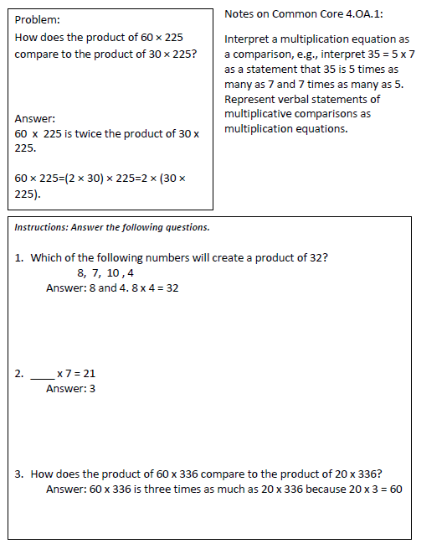

4.OA.2
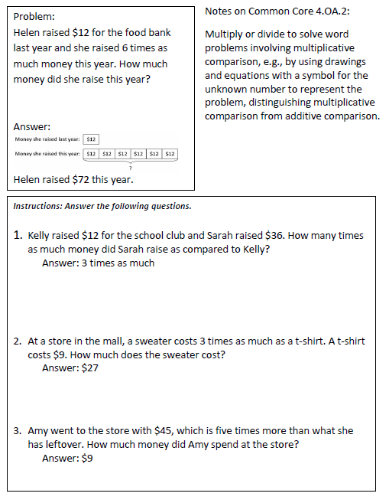

4.OA.3
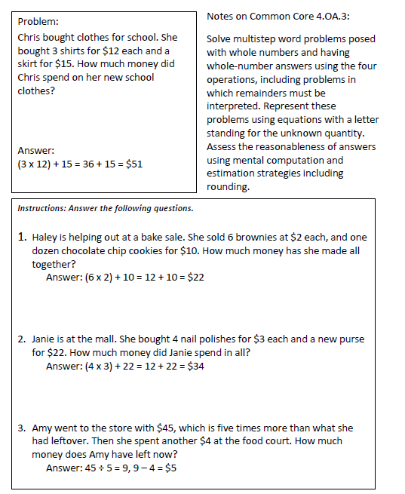

4.OA.4
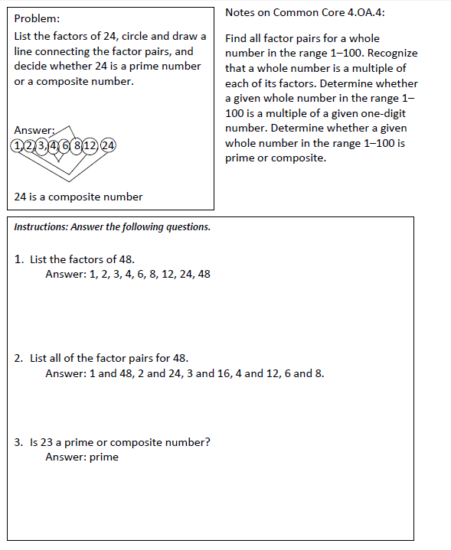

4.OA.5
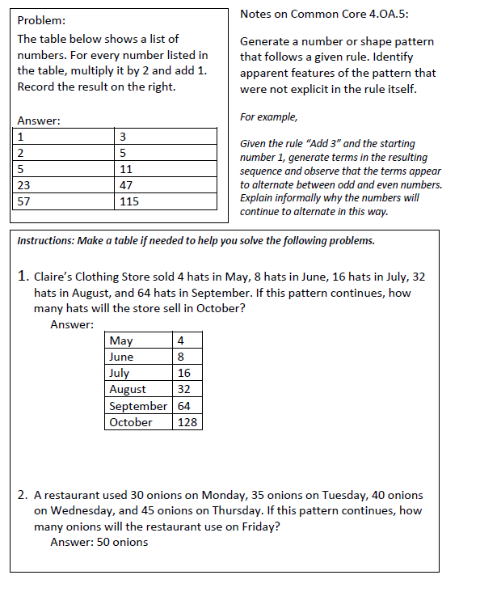

4.NBT.3
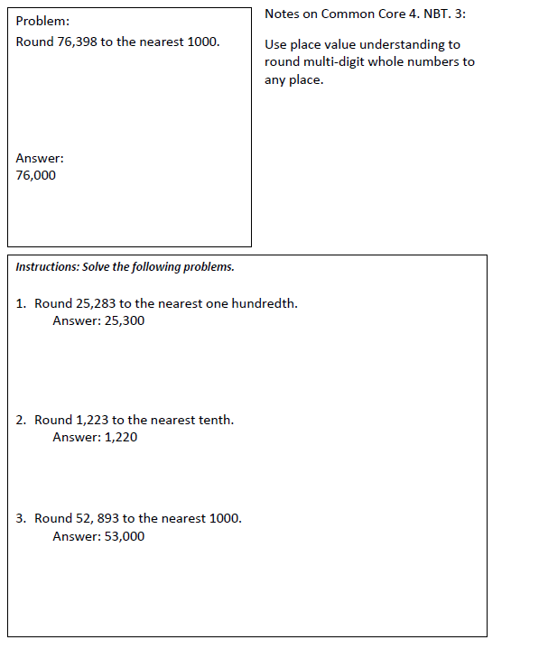

4.NBT.5
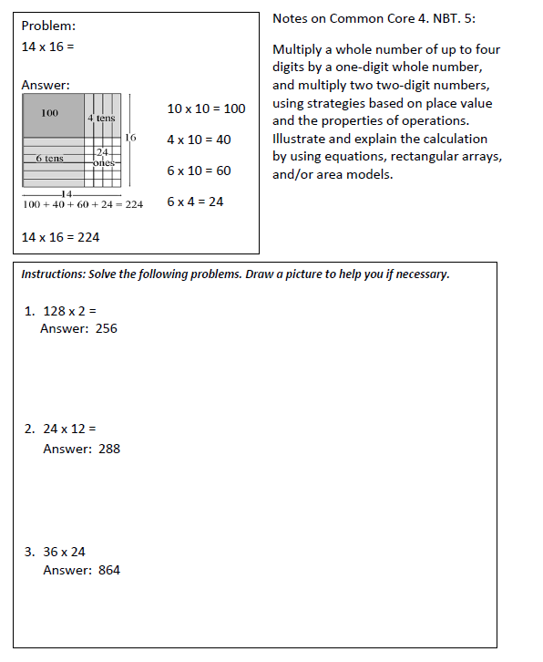

4.NF.7
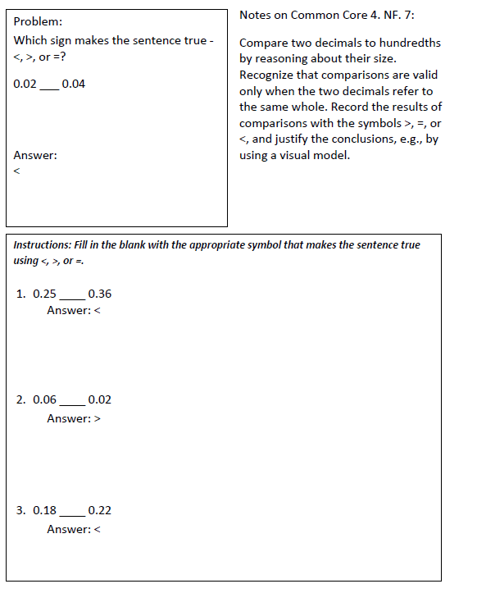

Extensions
Online Resources

4.OA.1

http://illuminations.nctm.org/LessonDetail.aspx?id=L872 – Factor Findings
http://illuminations.nctm.org/LessonDetail.aspx?ID=L528 – Finding Products http://illuminations.nctm.org/LessonDetail.aspx?ID=L529 – Multiplication Stories
http://illuminations.nctm.org/LessonDetail.aspx?ID=L272 – Playing the Product Game

4.OA.2
Comparing money raised http://s3.amazonaws.com/illustrativemathematics/illustration_pdfs/000/000/263/original/illustrative_mathematics_263.pdf?1381427006

4.OA.3
Karl’s Garden http://s3.amazonaws.com/illustrativemathematics/illustration_pdfs/000/000/876/original/illustrative_mathematics_876.pdf?1378591018

Carnival Tickets
http://s3.amazonaws.com/illustrativemathematics/illustration_pdfs/000/001/289/original/illustrative_mathematics_1289.pdf?1372632959

4.OA.4
The Locker Game
http://s3.amazonaws.com/illustrativemathematics/illustration_pdfs/000/000/938/original/illustrative_mathematics_938.pdf?1372632997

4.OA.5
Double Plus One
http://s3.amazonaws.com/illustrativemathematics/illustration_pdfs/000/000/487/original/illustrative_mathematics_487.pdf?1372632969

Multiples of Nine
http://s3.amazonaws.com/illustrativemathematics/illustration_pdfs/000/001/481/original/illustrative_mathematics_1481.pdf?1372632991

4.NF.7
Using Place Value http://s3.amazonaws.com/illustrativemathematics/illustration_pdfs/000/000/182/original/illustrative_mathematics_182.pdf?1372632953

Assessment Resources

4.OA.1
- Multiplication: Missing factors - facts to 12 (Fourth grade - D.2)
- Multiplication: Properties of multiplication (Fourth grade - D.7)
4.OA.2
- Multiplication: Estimate products: word problems (Fourth grade - D.9)
- Multiplication: Multiply a 2-digit number by a 2-digit number: word problems (Fourth grade - D.12)
- Multiplication: Multiply a 2-digit number by a larger number: word problems (Fourth grade - D.16)
- Multiplication: Multiply numbers ending in zeroes: word problems (Fourth grade - D.18)
- Division: Division facts to 12: word problems (Fourth grade - E.2)
- Division: Divide larger numbers, one-digit divisors: word problems (Fourth grade - E.5)
- Division: Divide numbers ending in zeroes, multi-digit divisors: word problems (Fourth grade - E.14)
- Division: Divide by 2-digit numbers: word problems (Fourth grade - E.17)
- Division: Divide larger numbers by 2-digit numbers: word problems (Fourth grade - E.19)
- Mixed operations: Addition, subtraction, multiplication, and division word problems (Fourth grade - F.2)
- Mixed operations: Estimate sums, differences, products, and quotients: word problems (Fourth grade - F.3)
- Money: Price lists with multiplication (Fourth grade - M.7)
- Measurement: Compare customary units by multiplying (Fourth grade - N.3)
- Measurement: Convert between metric and customary units (Fourth grade - N.6)

4.OA.3
- Number sense: Rounding (Fourth grade - A.6)
- Division: Divide by 1-digit numbers: interpret remainders (Fourth grade - E.7)
- Mixed operations: Estimate sums, differences, products, and quotients: word problems (Fourth grade - F.3)
- Mixed operations: Multi-step word problems (Fourth grade - F.4)
- Mixed operations: Word problems with extra or missing information (Fourth grade - F.5)
- Mixed operations: Solve word problems using guess-and-check (Fourth grade - F.6)
- Mixed operations: Choose numbers with a particular sum, difference, product, or quotient (Fourth grade - F.7)
- Algebra: Write variable expressions: word problems (Fourth grade - G.2)
- Algebra: Write variable equations to represent word problems (Fourth grade - G.5)
- Logical reasoning: Guess two numbers based on sum and difference (Fourth grade - K.1)
- Logical reasoning: Guess two numbers based on sum, difference, product, and quotient (Fourth grade - K.2)

4.OA.4
- Number sense: Prime and composite numbers (Fourth grade - A.5)
- Multiplication: Choose the multiples of a given number up to 12 (Fourth grade - D.3)
- Multiplication: Identify factors (Fourth grade - D.4)
- Multiplication: Choose numbers with a particular product (Fourth grade - D.13)
- Division: Divisibility rules (Fourth grade - E.11)

4.OA.5
- Functions: Input/output tables with addition, subtraction, multiplication, and division (Fourth grade - H.1)
- Functions: Function tables (Fourth grade - H.2)
- Patterns and sequences: Geometric growth patterns (Fourth grade - L.1)
- Patterns and sequences: Increasing growth patterns (Fourth grade - L.2)
- Patterns and sequences: Numeric patterns: word problems (Fourth grade - L.3)
- Patterns and sequences: Patterns involving addition and multiplication (Fourth grade - L.4)
- Patterns and sequences: Mixed patterns review (Fourth grade - L.5)
- Time: Time patterns (Fourth grade - O.8)

4.NBT.3
- Number sense: Rounding (Fourth grade - A.6)
- Addition: Estimate sums (Fourth grade - B.8)
- Addition: Estimate sums: word problems (Fourth grade - B.9)
- Subtraction: Estimate differences (Fourth grade - C.6)
- Subtraction: Estimate differences: word problems (Fourth grade - C.7)
- Multiplication: Estimate products (Fourth grade - D.8)
- Division: Estimate quotients, one-digit divisors (Fourth grade - E.10)
- Division: Estimate quotients (Fourth grade - E.21)

4.NBT.5
- Multiplication: Multiply 1-digit numbers by larger numbers (Fourth grade - D.5)
- Multiplication: Multiplication patterns over increasing place values (Fourth grade - D.6)
- Multiplication: Properties of multiplication (Fourth grade - D.7)
- Multiplication: Multiply a 2-digit number by a 2-digit number: complete the missing steps (Fourth grade - D.10)
- Multiplication: Multiply a 2-digit number by a 2-digit number (Fourth grade - D.11)
- Multiplication: Multiply numbers ending in zeroes (Fourth grade - D.17)

4.NF.7
- Money: Compare money amounts (Fourth grade - M.1)
- Decimals: Compare decimal numbers (Fourth grade - T.10)
- Decimals: Put decimal numbers in order (Fourth grade - T.11)

District Approved
Common Core Resources

General Resources
Where’d the Standards originate?
http://www.youtube.com/watch?v=dnjbwJdcPjE&lr=1
Common Core Tools
http://commoncoretools.me/
http://www.ccsstoolbox.com/
http://www.achievethecore.org/steal-these-tools

Manipulatives
http://nlvm.usu.edu/en/nav/vlibrary.html
http://www.explorelearning.com/index.cfm?method=cResource.dspBrowseCorrelations&v=s&id=USA-000
http://www.thinkingblocks.com/

Problem Solving Resources

Illustrative Math Project
http://illustrativemathematics.org/standards/k8
http://illustrativemathematics.org/standards/hs
The site contains sets of tasks that illustrate the expectations of various CCSS in grades K–8 grade and high school. More tasks will be appearing over the coming weeks. Eventually the sets of tasks will include elaborated teaching tasks with detailed information about using them for instructional purposes, rubrics, and student work.

Inside Mathematics
http://www.insidemathematics.org/index.php/tools-for-teachers
Inside Mathematics showcases multiple ways for educators to begin to transform their teaching practices. On this site, educators can find materials and tasks developed by grade level and content area.

Mathematics Assessment Project (MAP)
Shell Centre/Mathematics Assessment Resource Services (MARS), University of Nottingham & UC Berkley
MAP formative assessment are anchored in the content described in the standards, focusing on the mathematical practices that are the major new challenge in the CCSS. The two complementary types are concept-focused lessons and problem-focused lessons. These lessons are designed to assess and develop students’ capacity to apply their mathematics flexibly to non-routine unstructured problems, both from the real world and within pure mathematics.

Formative Assessment Lessons (High School)
http://map.mathshell.org/materials/lessons.php
http://map.mathshell.org.uk/materials/tasks.php
IXL
http://www.ixl.com/

Sample Balance Math Tasks
http://www.nottingham.ac.uk/~ttzedweb/MARS/tasks/

New York City Department of Education
http://schools.nyc.gov/Academics/CommonCoreLibrary/SeeStudentWork/default.htm
NYC educators and national experts developed Common Core-aligned tasks embedded in units of study to support schools in implementation of the CCSSM.
Gates Foundations Tasks
http://www.gatesfoundation.org/college-ready-education/Documents/supporting-instruction-cards-math.pdf

Minnesota STEM Teachers’ Center
http://www.scimathmn.org/stemtc/frameworks/721-proportional-relationships

Singapore Math Tests K-12
http://www.misskoh.com

Math Score:
Math practices and assessments online developed by MIT graduates.
http://www.mathscore.com/

Massachusetts Comprehensive Assessment System
www.doe.mass.edu/mcas/search

Performance Assessment Links in Math (PALM)
PALM is currently being developed as an on-line, standards-based, resource bank of mathematics performance assessment tasks indexed via the National Council of Teachers of Mathematics (NCTM).
http://palm.sri.com/

Mathematics Vision Project
http://www.mathematicsvisionproject.org/

Assessment Resources
  - Illustrative Math: http://illustrativemathematics.org/
  - PARCC: http://www.parcconline.org/samples/item-task-prototypes
  - NJDOE: http://www.state.nj.us/education/modelcurriculum/math/ (username: model; password: curriculum)
  - DANA: http://www.ccsstoolbox.com/parcc/PARCCPrototype_main.html
  - New York: http://www.p12.nysed.gov/assessment/common-core-sample-questions/
  - Delaware: http://www.doe.k12.de.us/assessment/CCSS-comparison-docs.shtml

PARCC Prototyping Project
Elementary Tasks (ctrl+click) | Middle Level Tasks (ctrl+click) | High School Tasks (ctrl+click)
- Flower gardens (grade 3)  - Fractions on the number line (grade 3)  - Mariana’s fractions (grade 3)  - School mural (grade 3)  - Buses, vans, and cars (grade 4)  - Deer in the park (grade 4)  - Numbers of stadium seats (grade 4)  - Ordering juice drinks (grade 4) | - Cake weighing (grade 6)  - Gasoline consumption (grade 6)  - Inches and centimeters (grade 6)  - Anne’s family trip (grade 7)  - School supplies (grade 7)  - Spicy veggies (grade 7)  - TV sales (grade 7) | - Cellular growth  - Golf balls in water  - Isabella’s credit card  - Rabbit populations  - Transforming graphs of quadratic functions

Professional Development Resources
Edmodo
http://www.edmodo.com
Course: iibn34

Clark County School District Wiki Teacher
http://www.wiki-teacher.com/wikiDevelopment/unwrappedSearch.php#contentAreaId=6&courseId=474

Learner Express Modules for Teaching and Learning
http://www.learner.org/series/modules/express/videos/video_clips.html?type=1&subject=math

Additional Videos
http://www.achieve.org/achieving-common-core; http://www.youtube.com/user/TheHuntInstitute/videos

Mathematical Practices
Inside Mathematics
http://www.insidemathematics.org/index.php/commmon-core-math-intro
Also see the Tools for Educators

Mathematics Assessment Project
http://map.mathshell.org/materials/stds.php?id=1158

The Teaching Channel
https://www.teachingchannel.org

Learnzillion
https://www.learnzillion.com

Engage NY
http://www.engageny.org/video-library?f[0]=im_field_subject%3A19

